**My Shift Cloud4c tickets types**

**INTERNAL TICKET TYPE**

1. **TASK TICKET: TSK101035792**

* Open the Myshift portal the page is display as shown in the below screen shot.

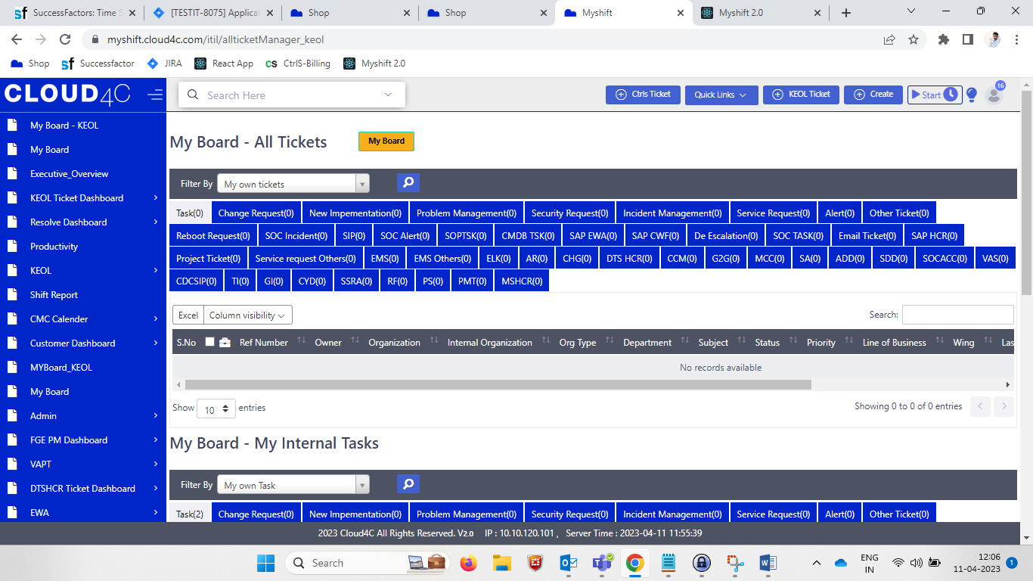

* Click on KEOL ticket button

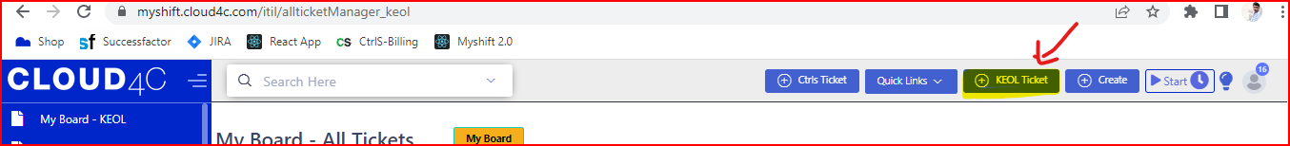

* By clicking on the KEOL ticket button, the **NEW TICKET** tab/popup will display along with the details as shown in the below screen shot.

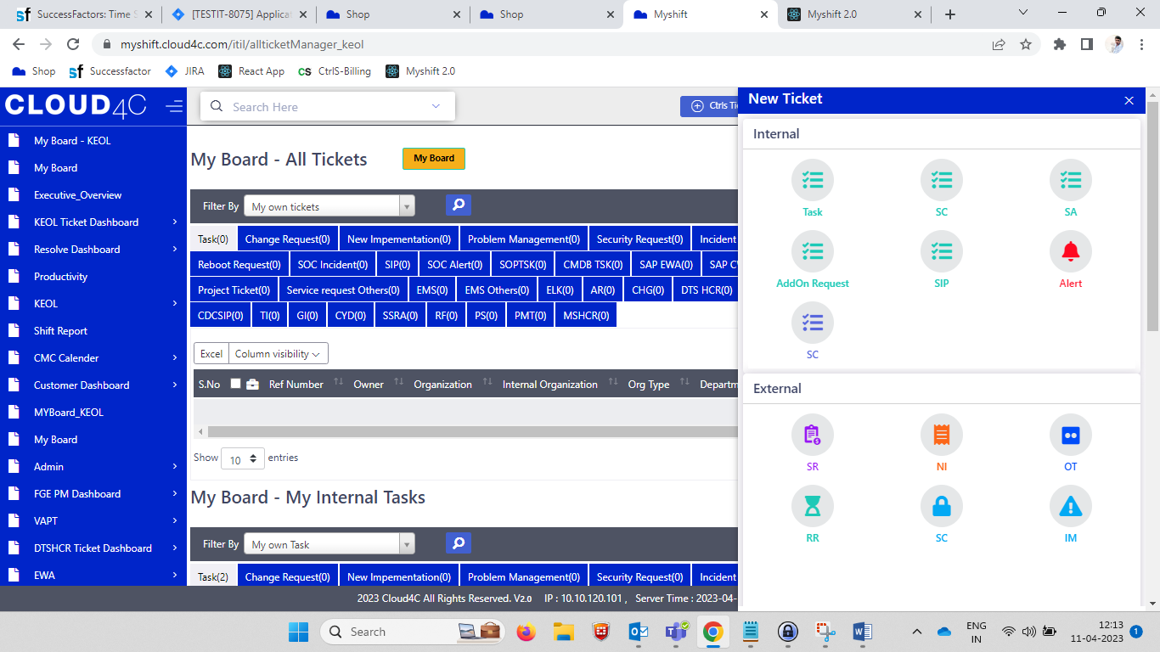

* Click on the **TASK** icon the tab will be display along with the details as shown in the below screen shot.
* The details are **Subject, Department, Organization, User, Priority, Description, Attachment, Submit button and Close button** as shown in the below screen shot.

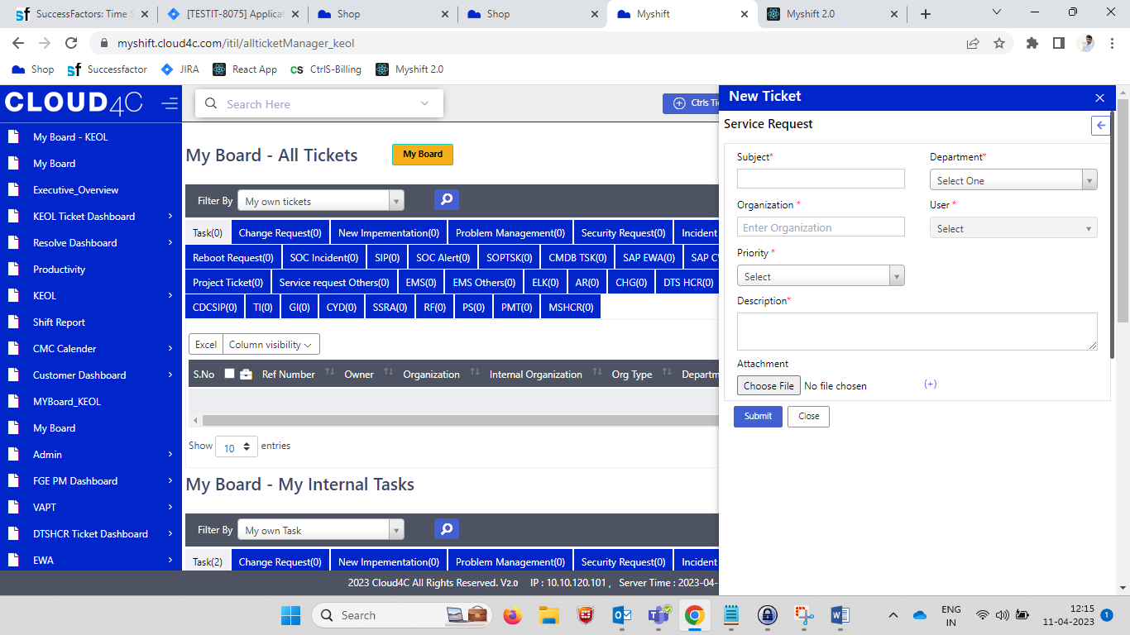

**NOTE:** All the **fields** and **dropdowns** should be **MANDATORY** except **Attachment.**

* Based on the **USER PROFILE, DEPARTMENT** list will be changed.
* In **Department,** the field should be in **Dropdown** along with the respective department fields as per ticket type.

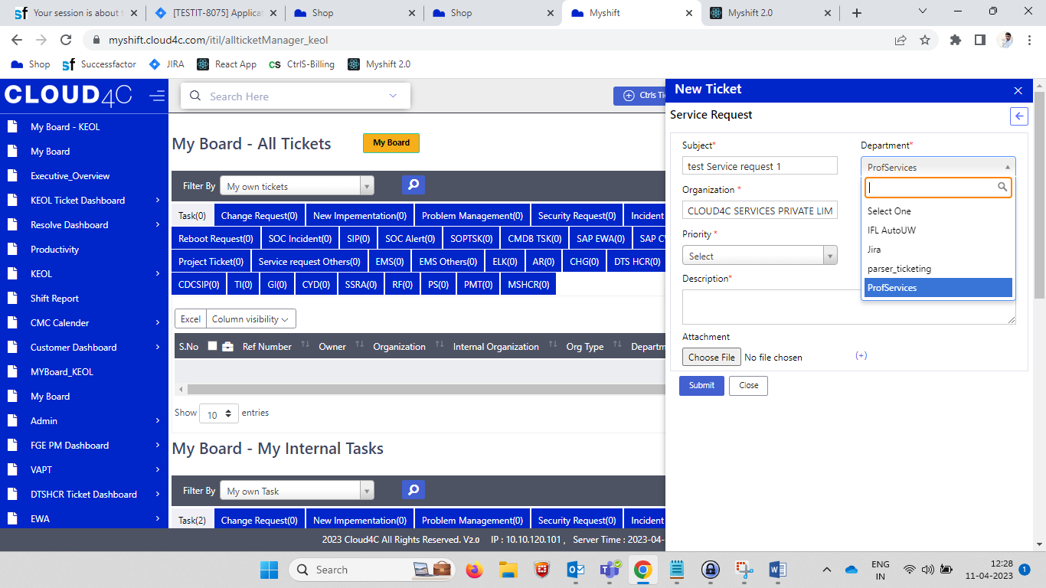

* In **Organization** field by selecting the field the organization list should be display as shown in the screen shot.

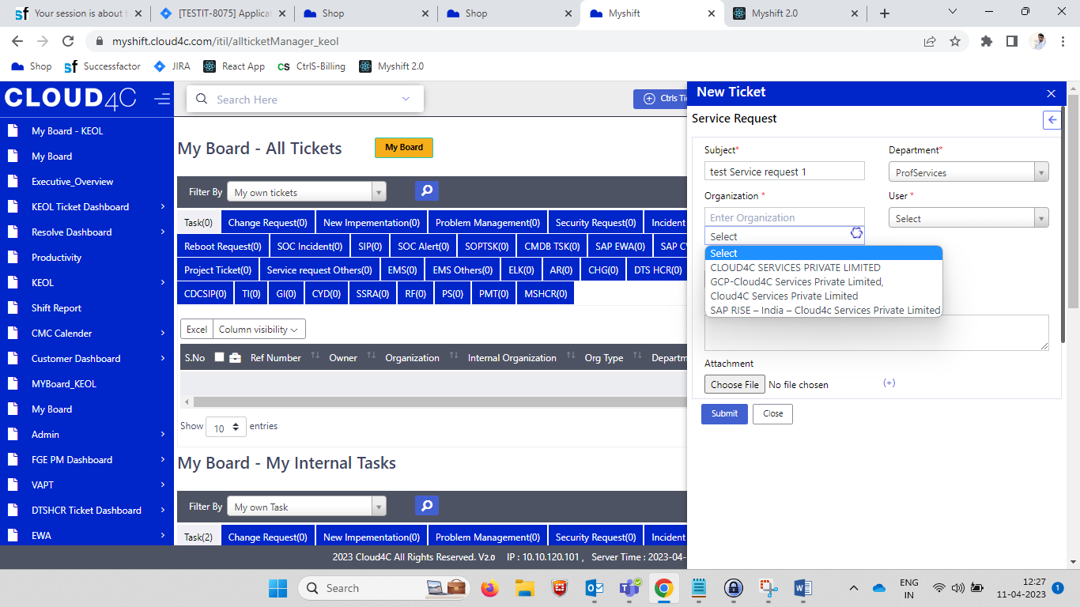

* In **USER** field should be in **Dropdown,** in the Dropdown the details should be display as per the selected organization.

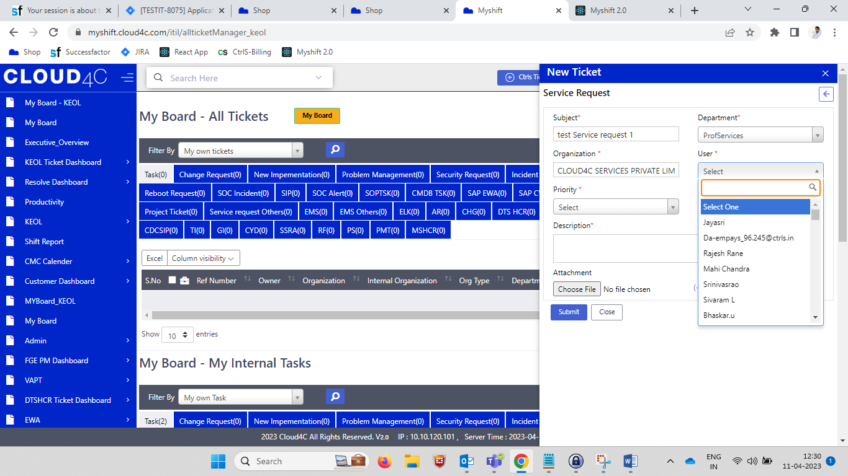

* In **priority,** the field should be Dropdown along with the list as shown in the below screen shots dropdown.

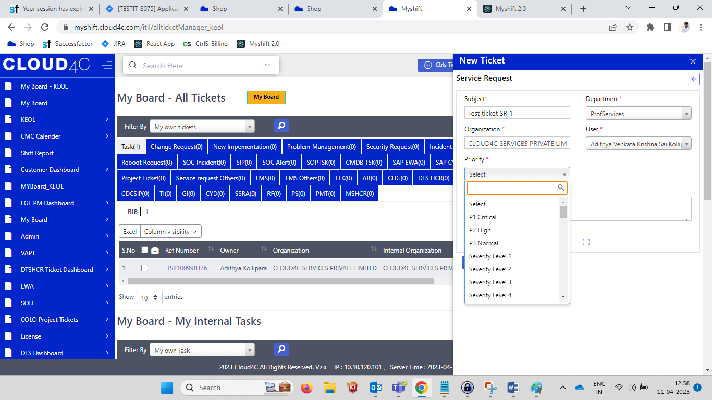

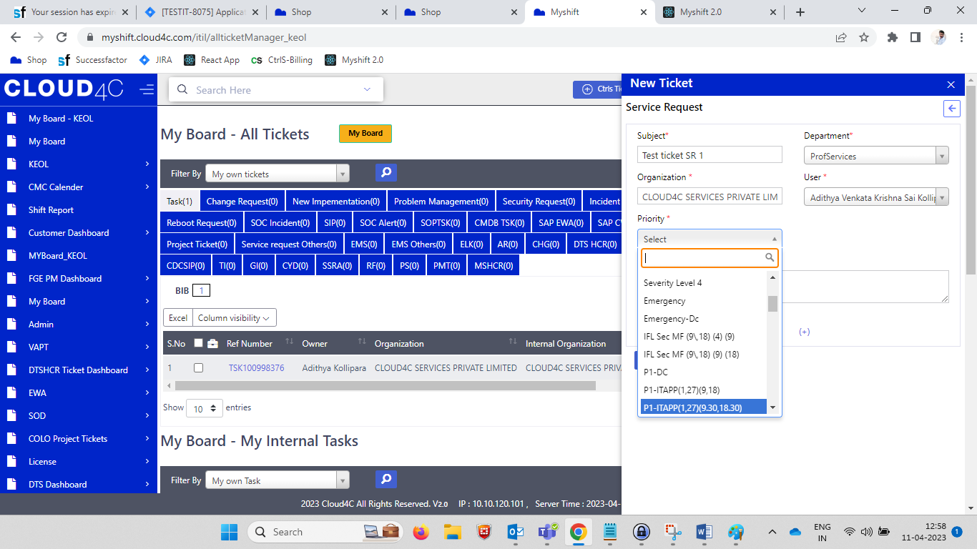

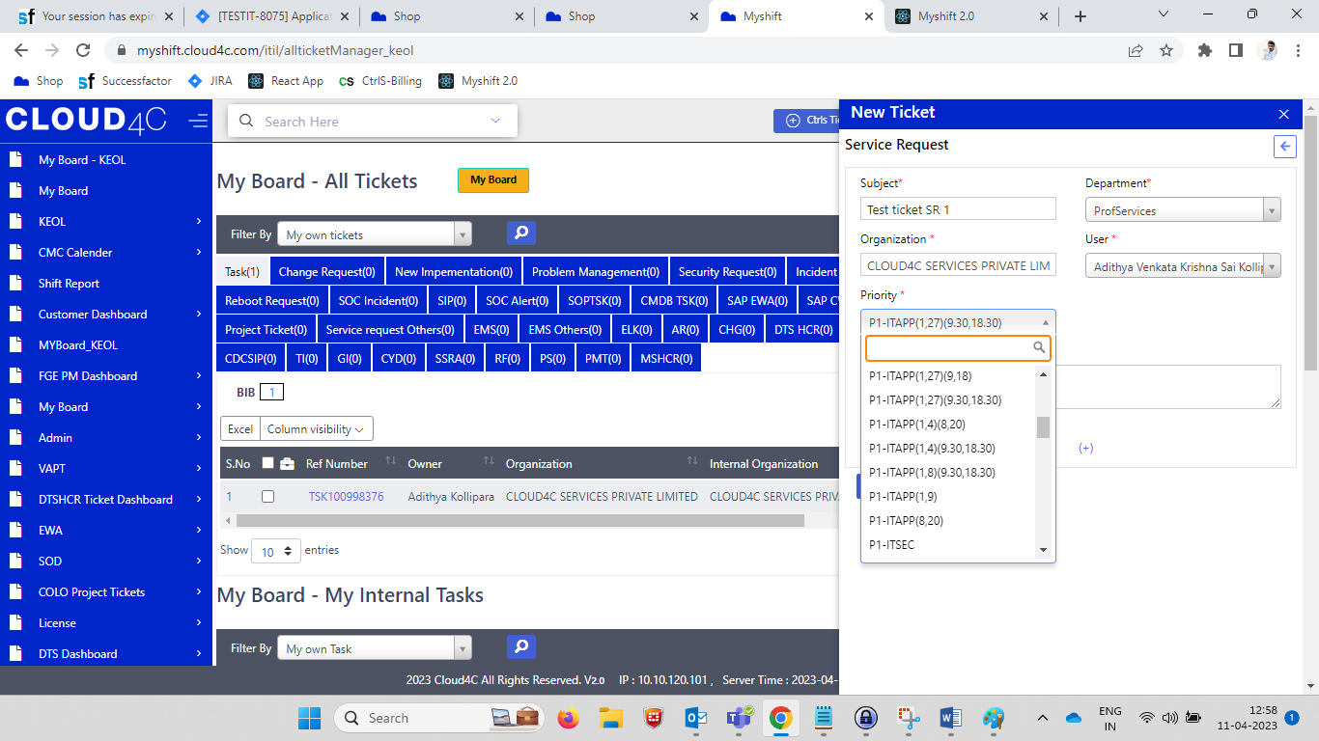 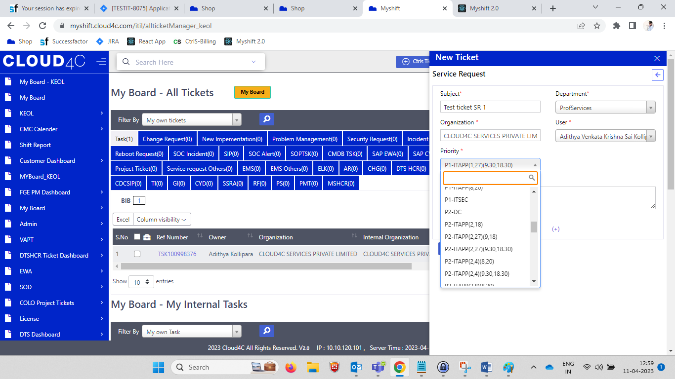 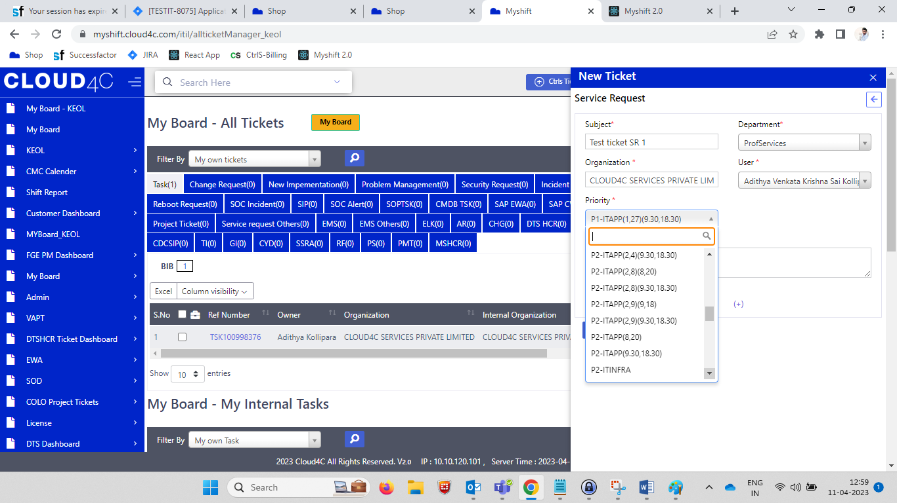 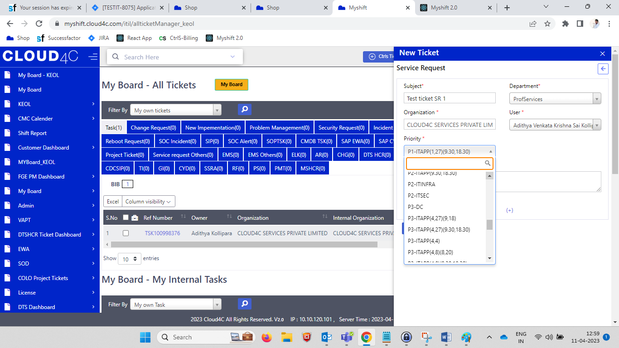 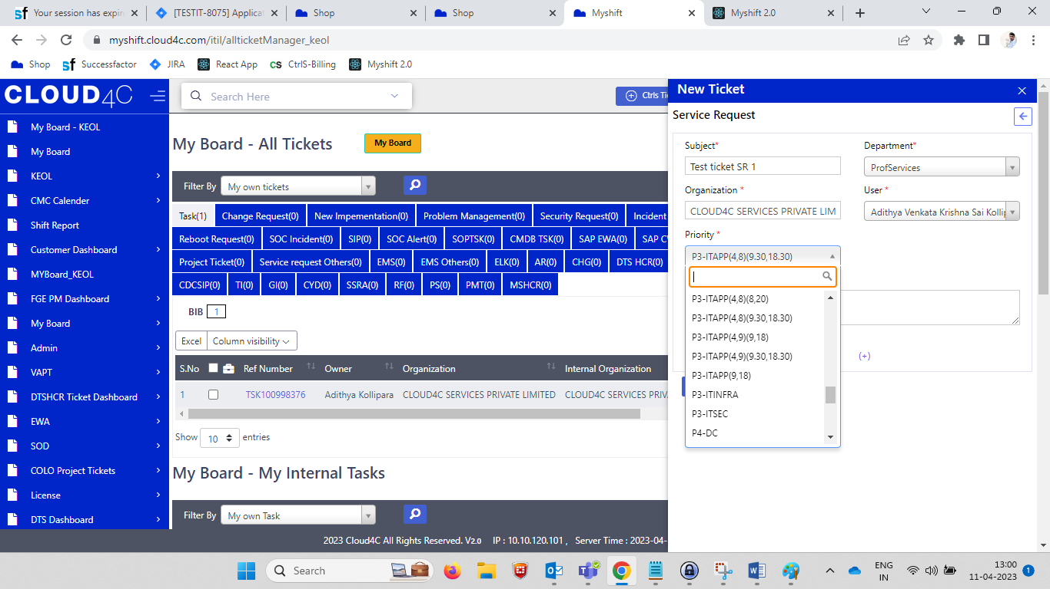 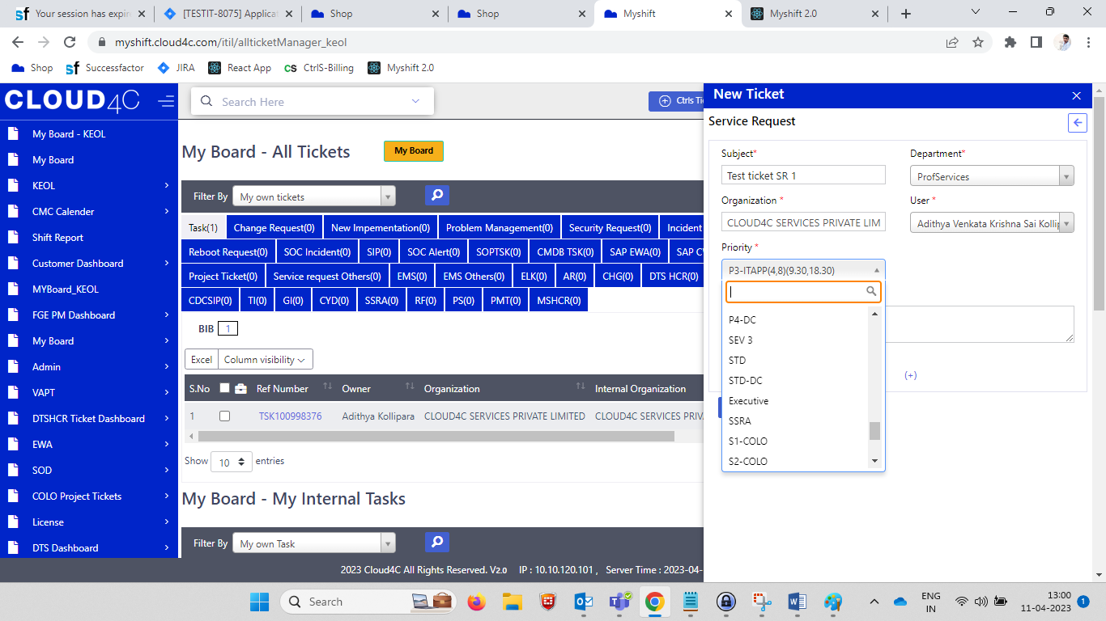 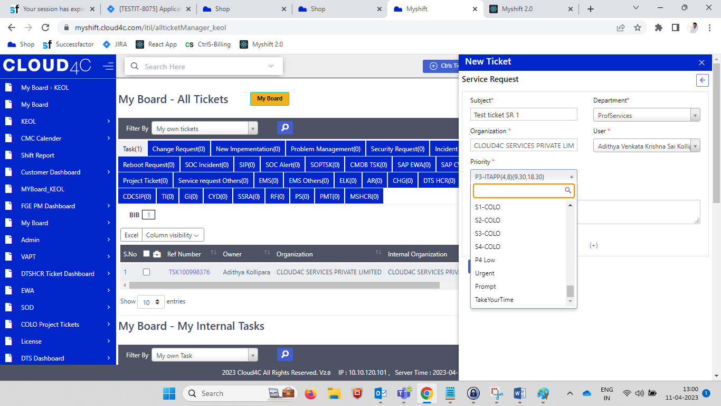

* In **Description**, the field should be in TEXT box as shown in the below screen shot.

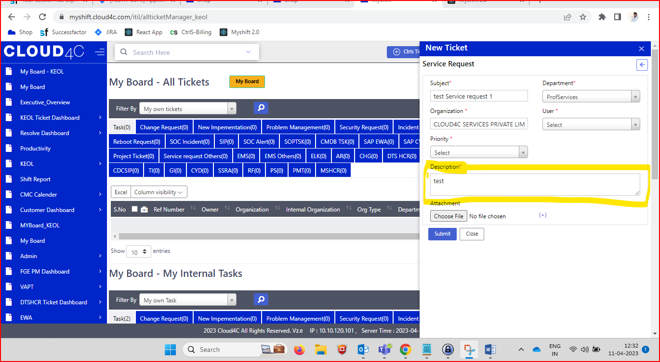

* In **Attachment**  field, it should be like **Choose file** button along with the **No file chosen** test along with the PLUS(+) symbol as shown in the below Screen shot.

**NOTE:** By clicking on the Choose file button it should navigate system files.

By Clicking on **PLUS (+)** button the Another **Choose file** button along with the **Close/cancel (x)** symbol as shown I the below screen shot.

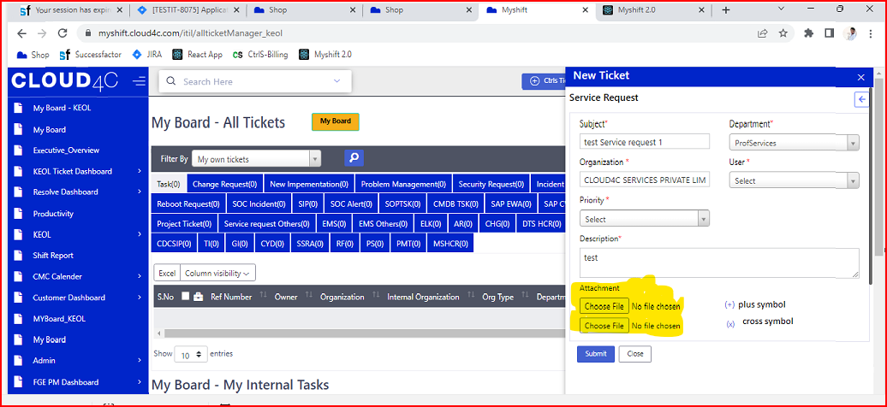

* By clicking on **Close** Button the **new ticket** tab should be close.
* By clicking on **Submit** button it should show the Successful popup and navigate to ticket details page as shown in the below screen shot.

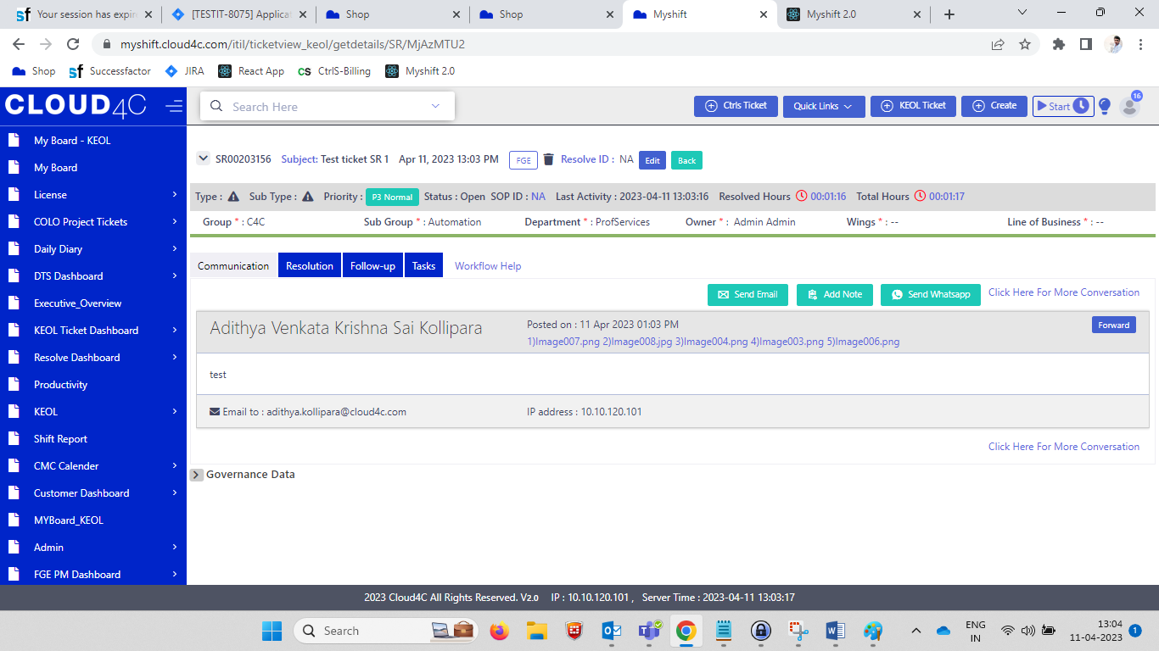

* As per the above screen shot the details should be display along with the **EDIT** and **BACK** buttons.

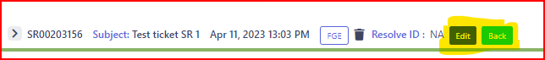

* **TICKET ID** Should be display after creating the ticket as shown in the below screen shot.

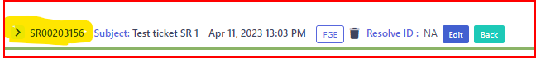

* **SUBJECT and CREATED DATE AND TIME** should be display as per the User type in the ticket creation page.

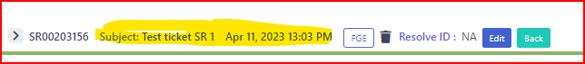

* **FGE (organization category), RESOLVE ID** and **DELETE** icon Should be display as shown in the below screen shot.

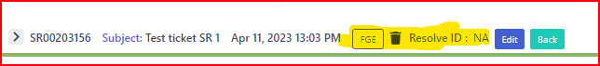

* By clicking on the **DELETE** icon/ Trash BOX, the below Confirmation POP UP will be display as shown in the below screen shot.

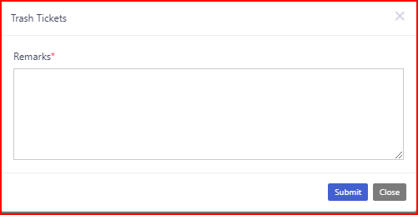

* In the TRASH TICKETS Popup the below highlighted Details Should be display as shown in the below Screen Shot.

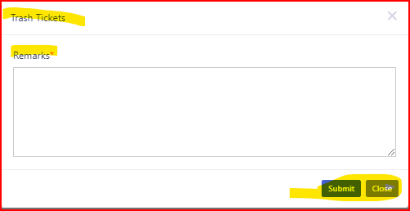

* By Clicking on the **CLOSE** Button the POPUP Should be disappear.
* By Clicking on the **SUBMIT** button the confirmation popup with highlighted details should be display as shown in the below screen shot.

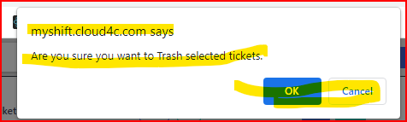

* By clicking on the **OK** button the ticket Should be trash
* By clicking on the **Cancel** button the ticket should not be trashed and the popup should be disappear.
* By clicking on the **EDIT** button the page should be in editable and should display **UPDATE, CANCEL, BACK, CONVERT TO EXTERNAL** buttons etc.., as shown in the below screen shot



* By clicking on the **CANCEL Button** the page should be display in **edit** as shown in the screen shot.

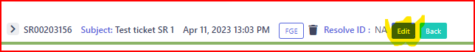

* By clicking on **UPDATE** button, the below details should be display as shown in the below Screen Shot.
* The Highlighted details are shown in the below Screen shot.

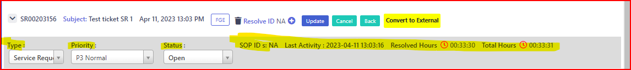

* For the **TYPE** should have the Dropdowns along with list as shown in the Below Screen shots.

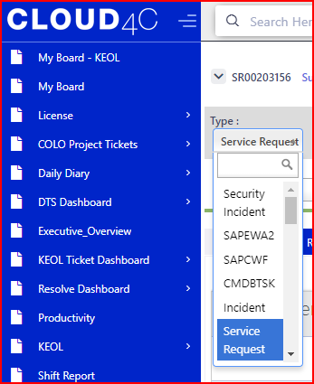 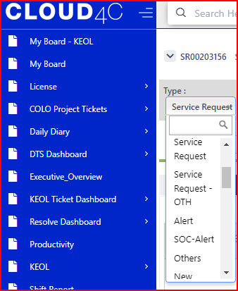 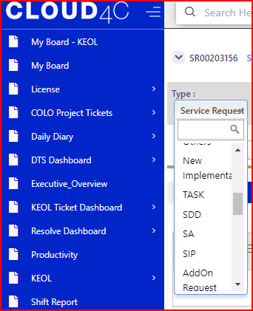 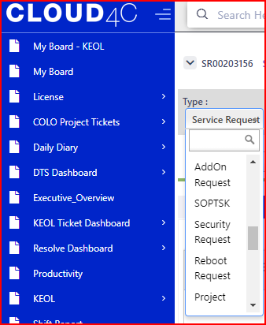

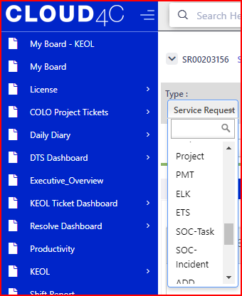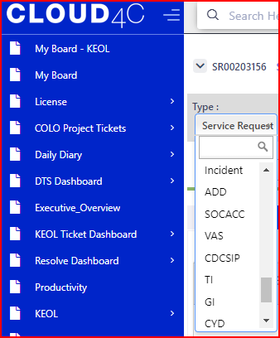

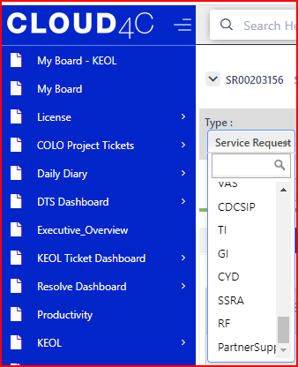

* For the **priority** should have the Dropdowns along with list as shown in the Below Screen shots.

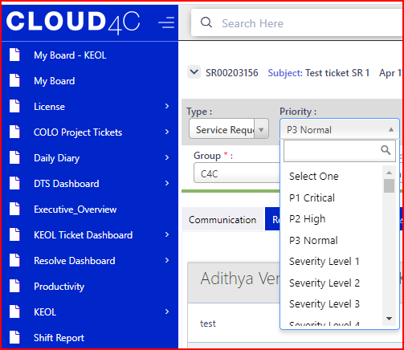 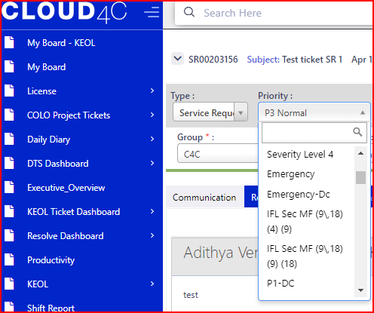 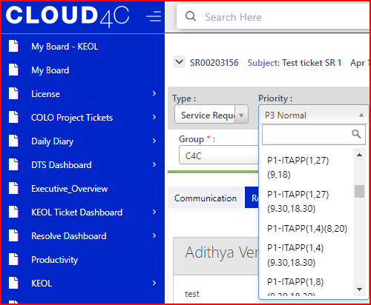 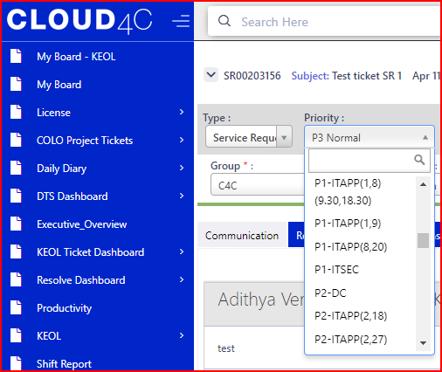 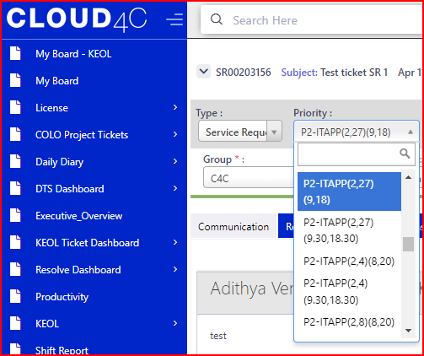 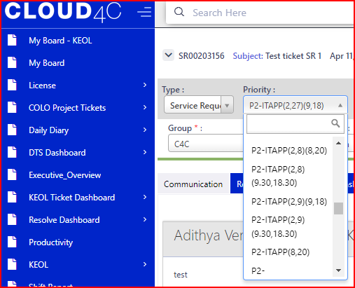 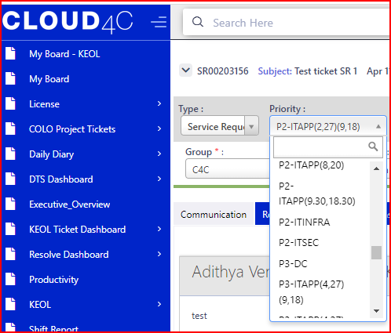 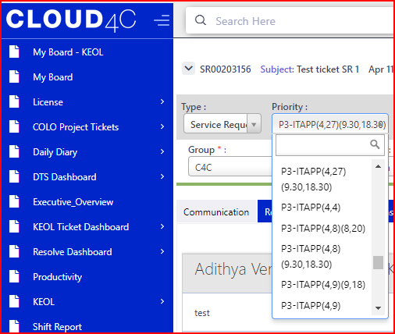 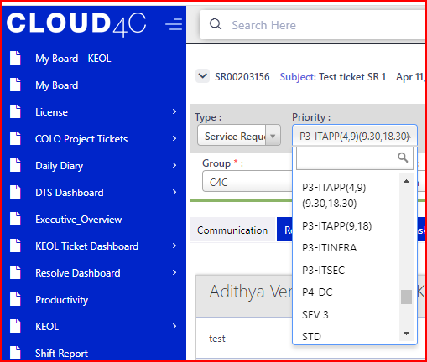 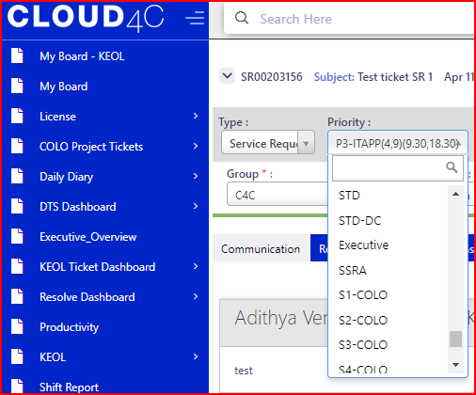

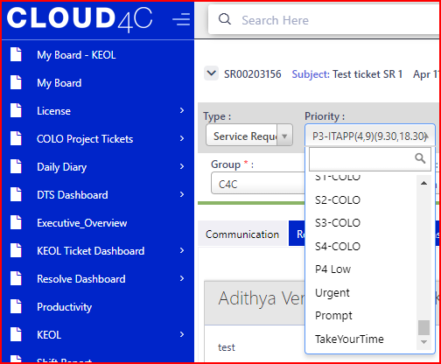

* For **OPEN** field should have the Dropdowns along with list as shown in the Below Screen shots.
* The Details Are **OPEN, ACTIVITY, CLOSED, PENDING ON CUSTOMER, PENDING ON MANAGEMENT** as shown in the below screen shot

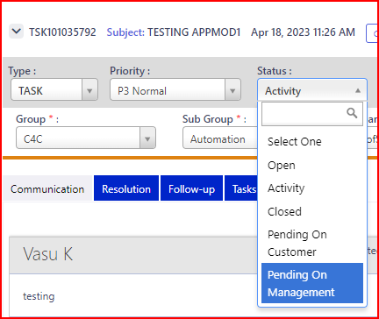

**NOTE:**  The **SOP ID’s Resolved hours** and **total hours** should be displayas shown in the below screen shot.

The **Resolved Hours** and **Total hours** Should run the time continusly.

All the fields should be mandatory and should have the * symbol.



* In the ticket page we should have the highlighted details as shown in the screen shot.
* All the Fields are mandatory and should display the * symbol.

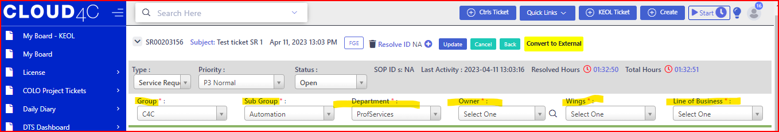

* For **GROUP**  field should have the dropdown along with the details as shown in the below screen shots.

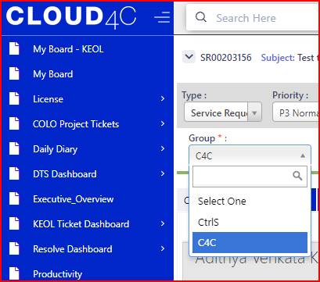

* For **OWNER,** field should have the dropdown, based on **GROUP** and **SUBGROUP** Selection the details should display in the **OWNER** dropdown as shown in the below screen Shots.

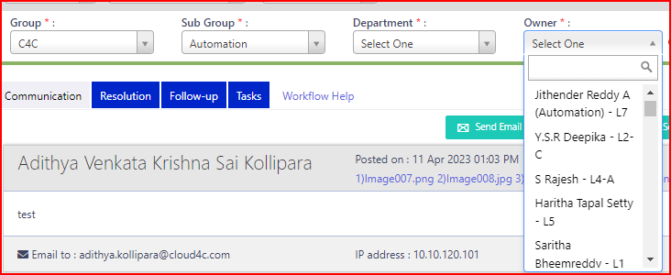

* For **SUB GROUP** field Should have the drop down as per the selection of group the details Should be display in the dropdown list as shown in the screen shot.
* Based on the **GROUP** selection, in the **SUB GROUP** dropdown the details should be display.
* For example if user select the group as **C4C** in the Sub group dropdown list should be changed as shown in the below screen shot.

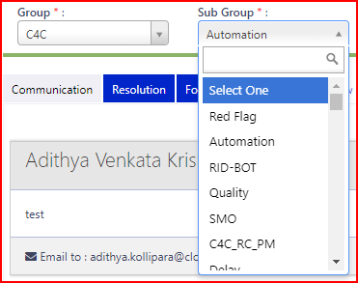 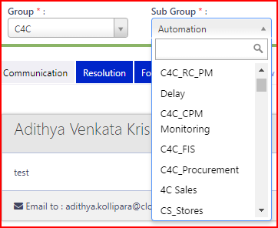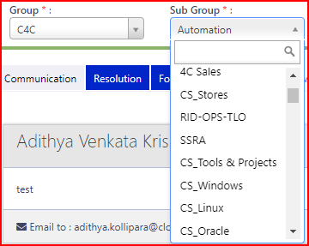 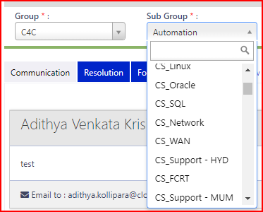 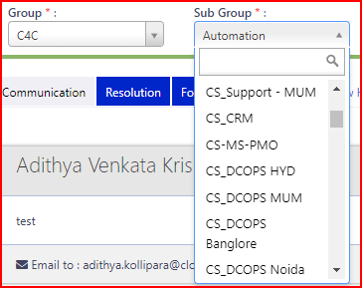 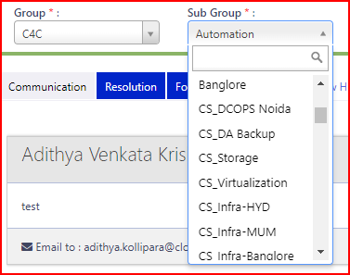 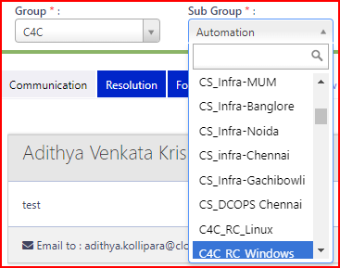 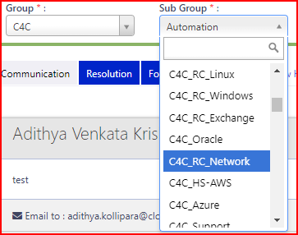 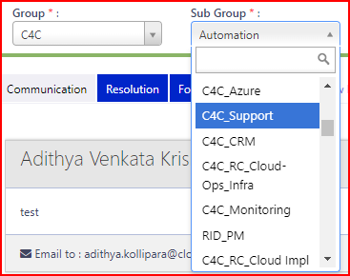 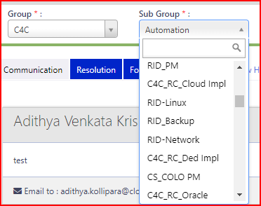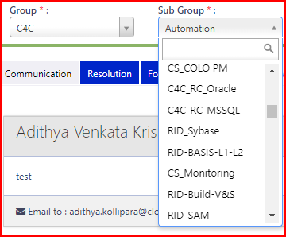 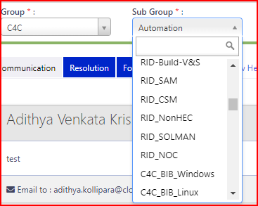 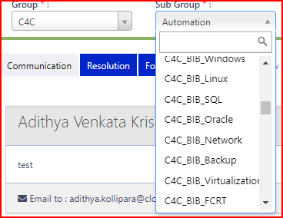 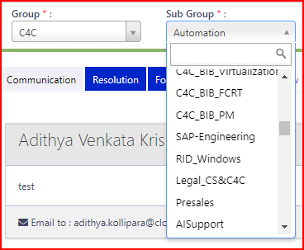 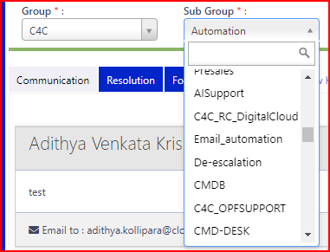 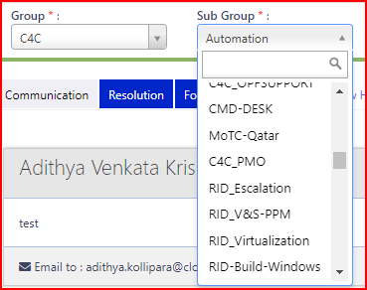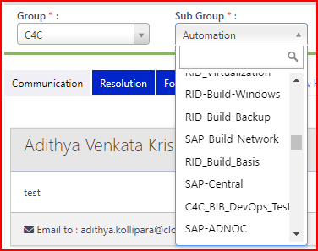 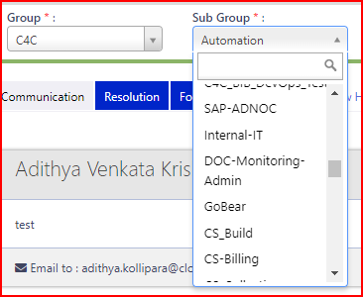

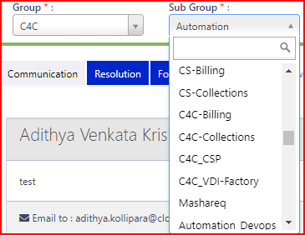 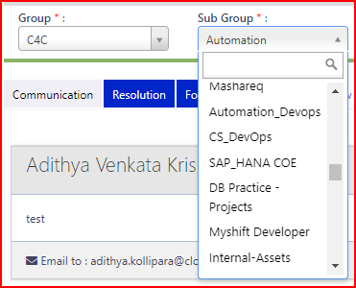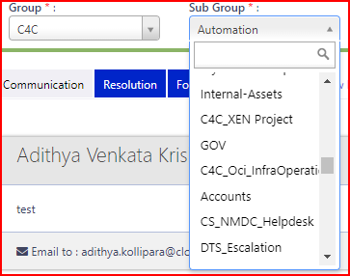 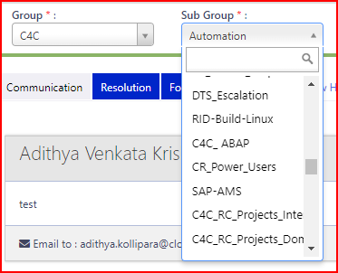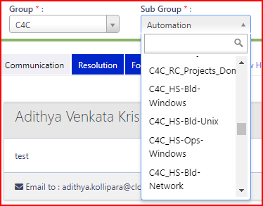 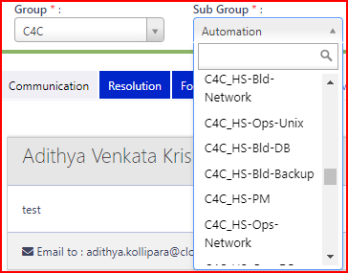

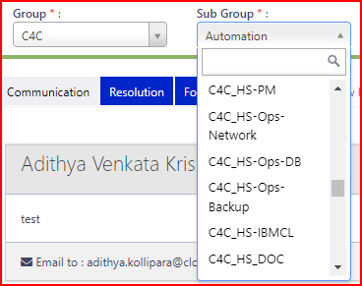 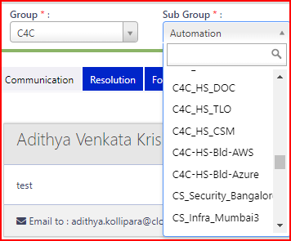 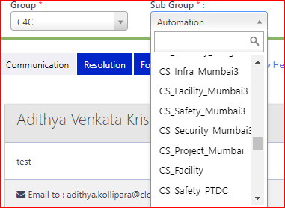 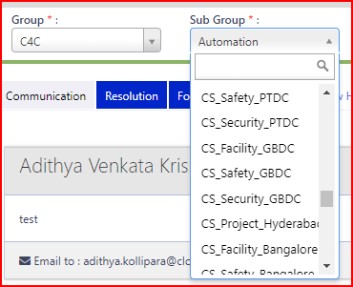 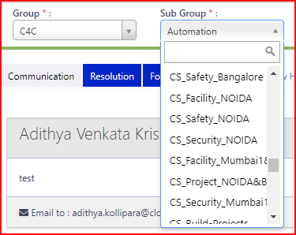 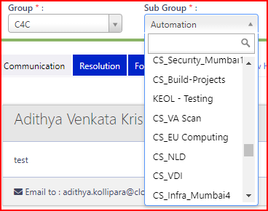

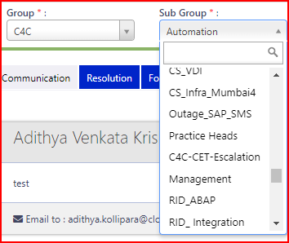 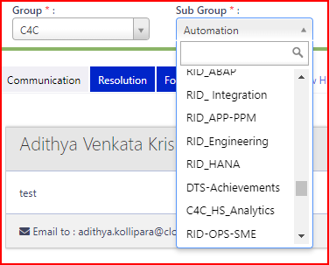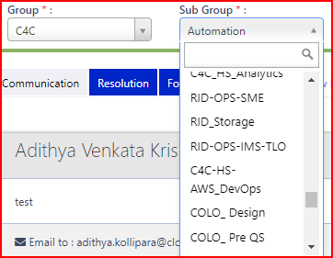 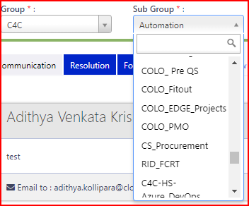

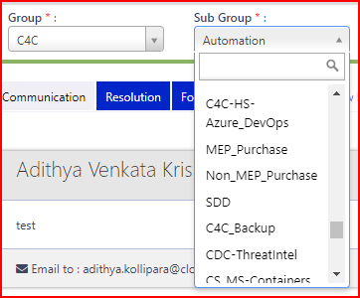 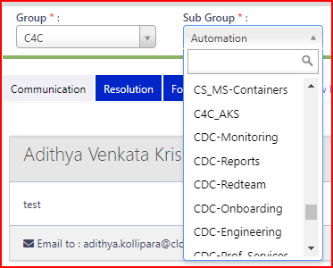

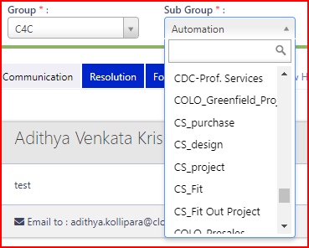 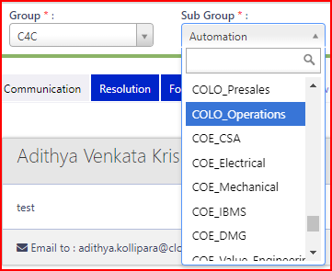

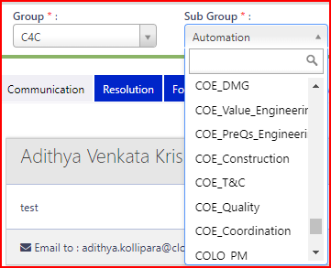 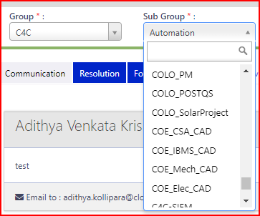

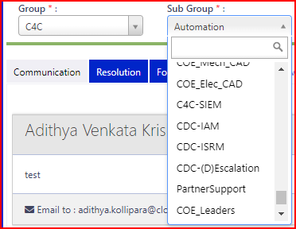 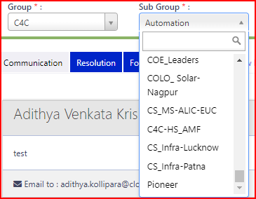

* For **Departments,** field should have the dropdown, based on **GROUP** and **SUBGROUP** Selection the details should display in the department dropdown as shown in the below screen Shots.

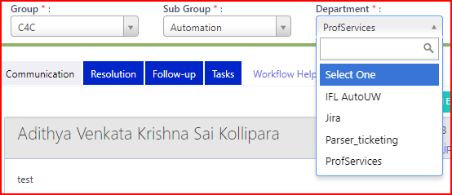

* For **WINGS,** field should have the dropdown, based on **GROUP** and **SUBGROUP** Selection the details should display in the **WINGS** dropdown as shown in the below screen Shots.

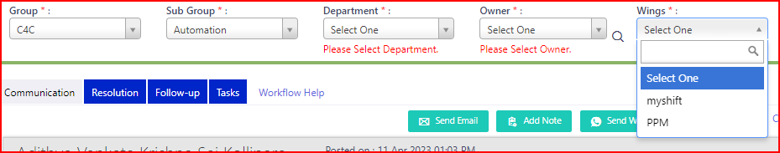

* For **Line of bussiness** field should have the dropdown, based on **GROUP** and **SUBGROUP** Selection the details should display in the **LINE OF BUSSINESS** dropdown as shown in the below screen Shots.

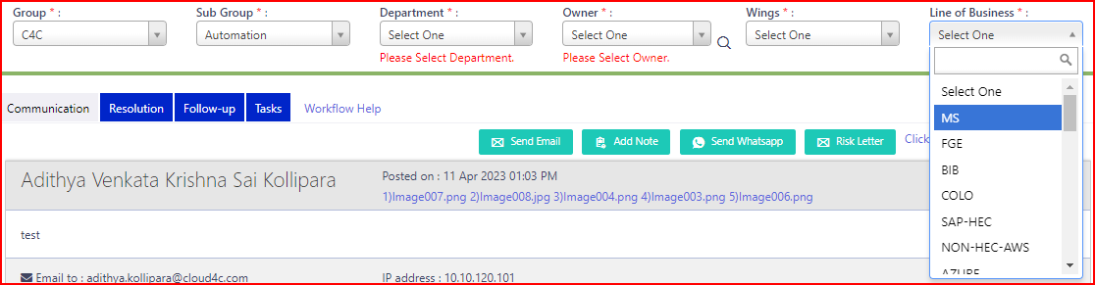 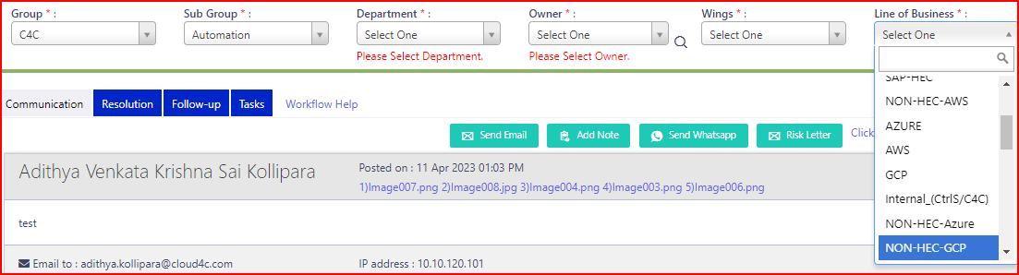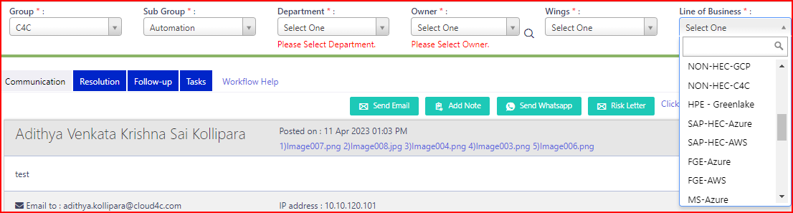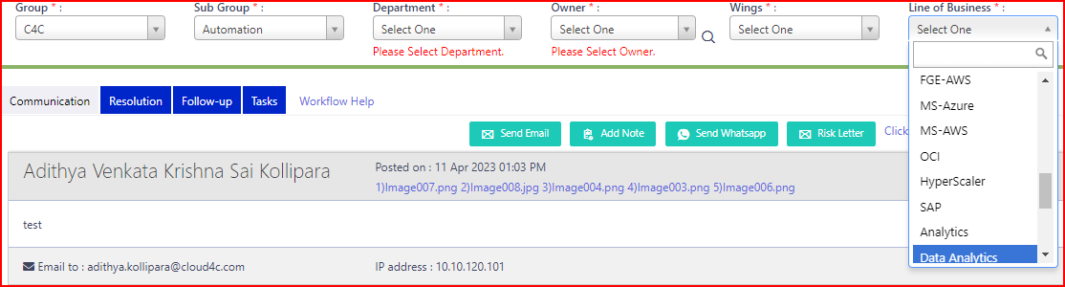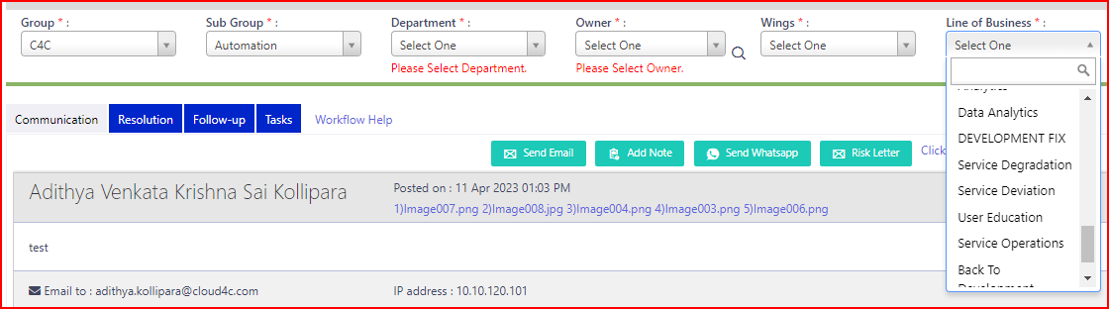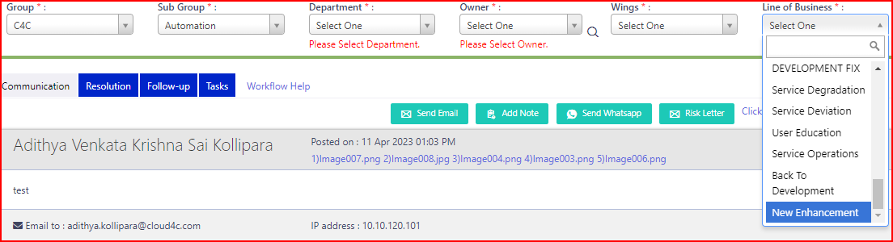

**NOTE:** All the Above Fields Shoul be mandatory with * symbol and should not be in blank, if the fields are in blank it should show the Validations as shown in the Below screen shot.



* Fill all the mandatory details and click on **UPDATE** Button, the POPUP should be display with **OK** and **CANCEL** Buttons as shown in the below Screen shot.

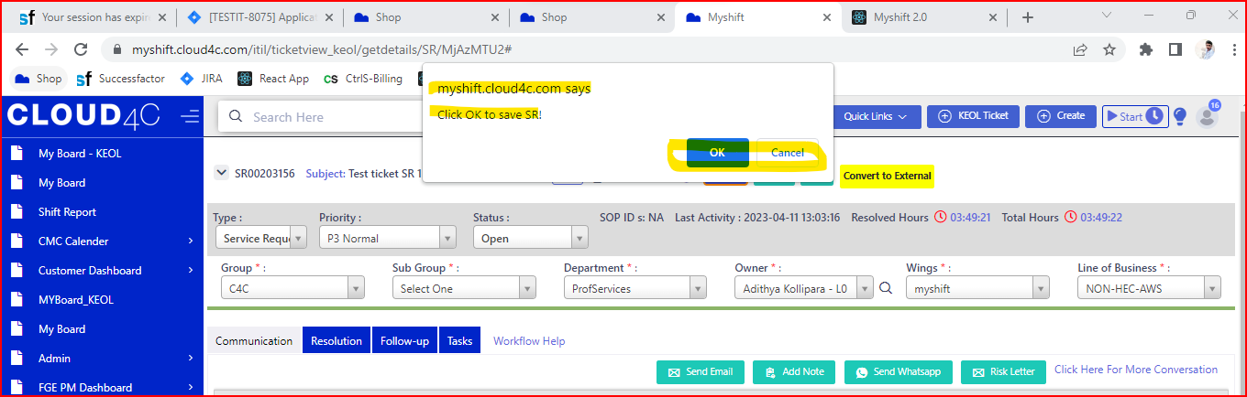

* By clicking on the **OK** Button the page should be display as shown in the Below Screen Shot.

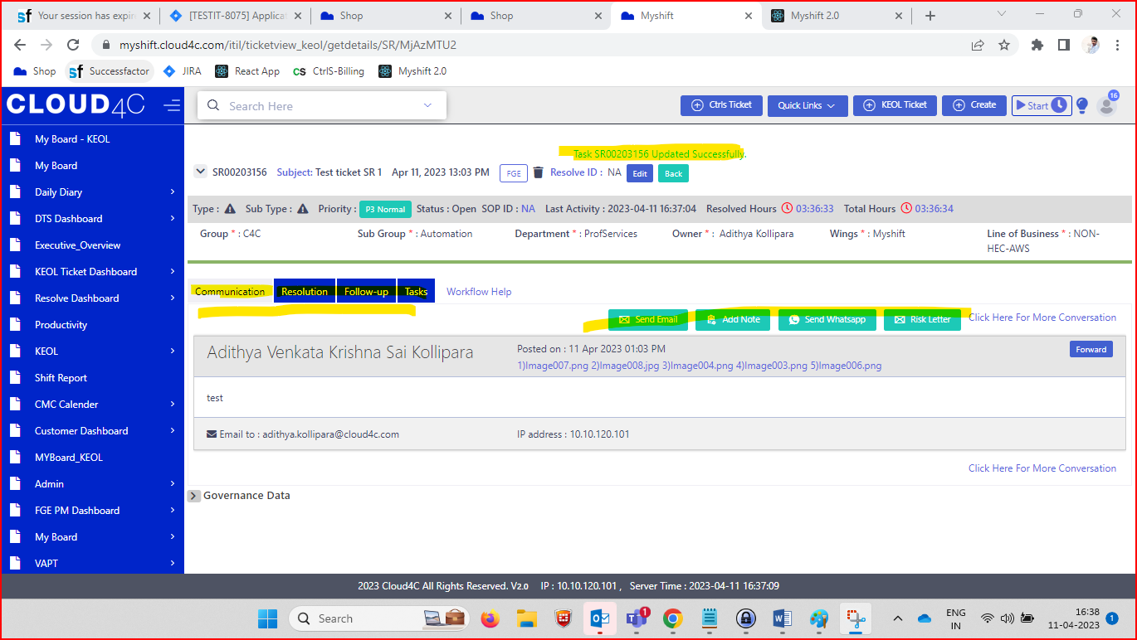

* By Default, The page should be in **Communication** tab as shown in the Below Screen Shot.
* In Communication tab we can see the Communication Between the User and the Customer.

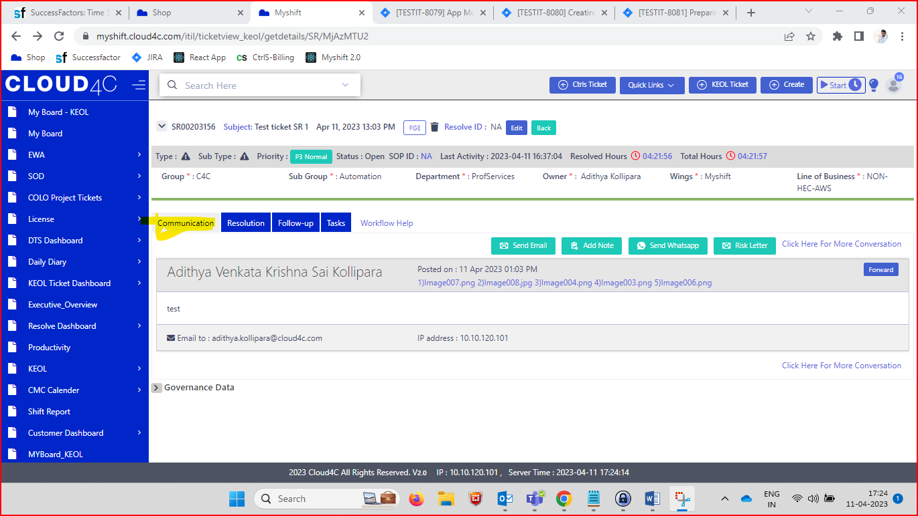

* In **Comunication tab** We can see the Below Icons/ tabs they are **SEND EMAIL, ADDNOTE, SEND WHATSUP, RISK LETTER and CLICK HERE FOR MORE CONVERSATION link** As shown in the Below Screen Shot.



* By Clicking on the **SEND EMAIL** Button the email tab/ model will open as shown in the Below Screen shot.

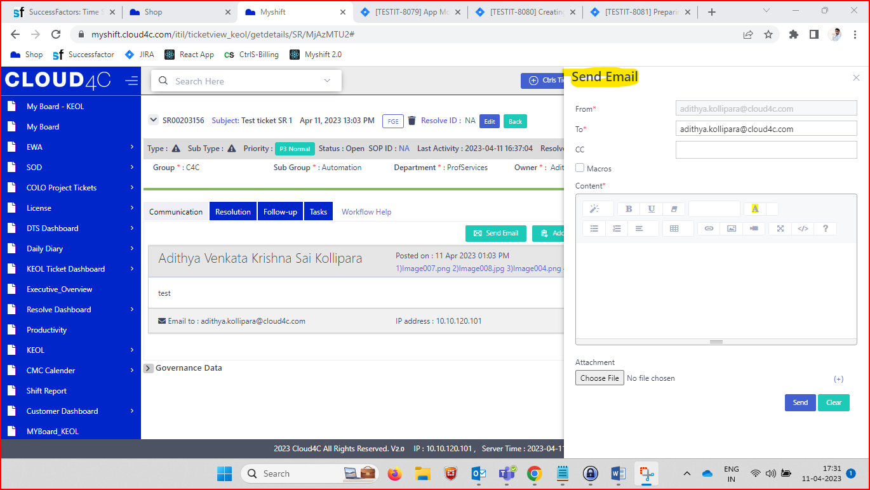

* In send email tab we have the below details i.e.., From, To, CC, Macrons, Content, ATTACHMENT, Send and Clear buttons as shown in the below Screen shot.
* The **FROM, TO, CONTENT** Fields Should be in **MANDATORY WITH * SYMBOL.**

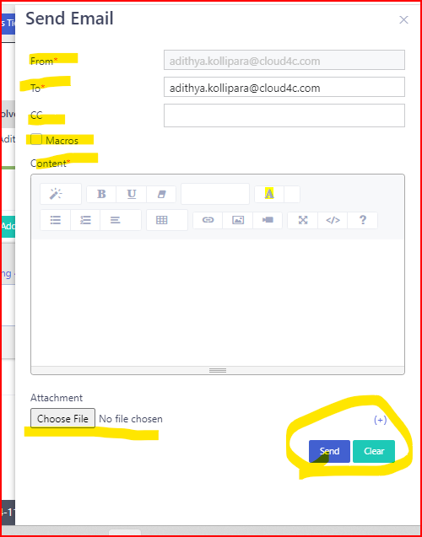

* By default **FROM** Address Should be display in Protected mode in the **From** Field as Shown in the Highlighted part in the below screen shot.

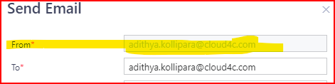

* The **TO** Address should be in editable Mode with in the text box as shown in the Below Screen shot

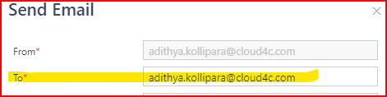

* The **CC** Field is non mandatory and it was in Editable mode as shown in the Screen shot.

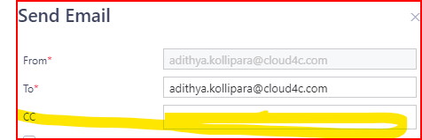

* For **MACRONS**  should have the Check Box and it was not mandatory
* By selecting the Check box for **MACRONS** the **MACRONS CATEGORY** Field Should be Display as Shown in the Below Screen Shot.

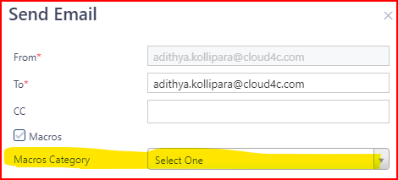

* For **MACRONS CATEGORY** should have the Drop down and show the below details as shown in the below screen shot.

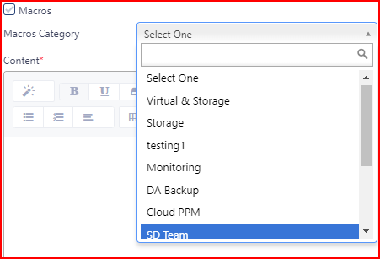 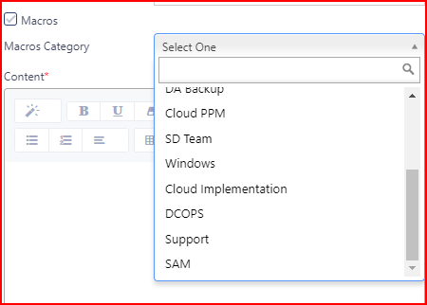

* For **Content,** the Field should be in TEST box with all types of icons like headers, font, styles etc.., as shown in the below Screen Shot.

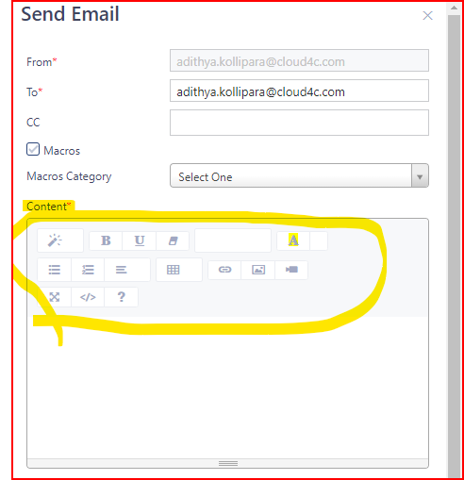

* In **Attachment**  field, it should be like **Choose file** button along with the **No file chosen** test along with the PLUS(+) symbol as shown in the below Screen shot.

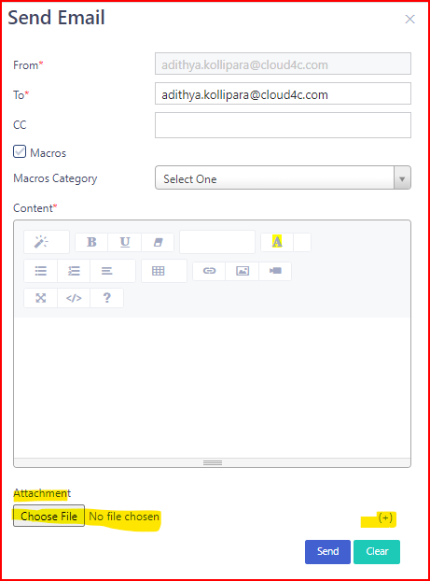

* By Clicking on the **Choose file** Button it should navigate to system files.
* By Clicking on **PLUS (+)** button the Another **Choose file** button along with the **Close/cancel (x)** symbol as shown I the below screen shot.

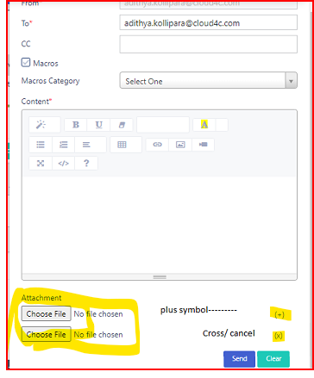

* By clicking on the **CLEAR** Button, the Confirmation POPUP Should be display along with **OK** and **CANCEL** buttons as shown in the below Screen Shot.

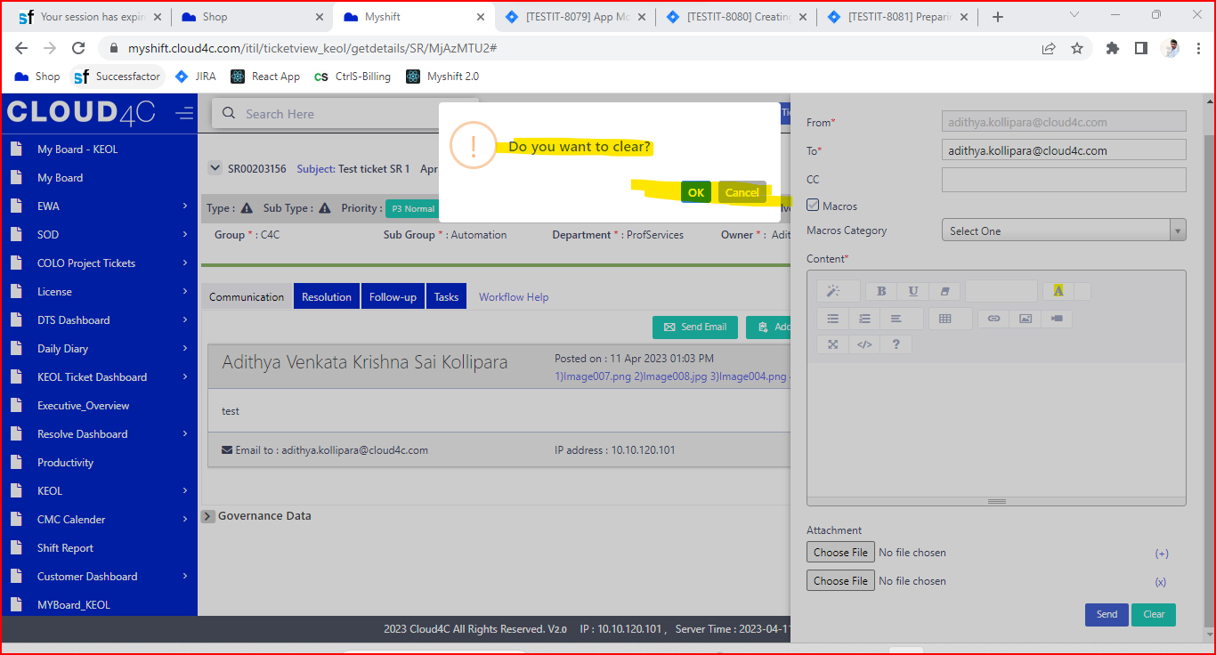

* By Clicking on the **CANCEL** Button in the Confirmation POPUP, it should be in Send Email page.
* By Clicking on the **OK** button in the confirmation **POPUP**, the details should be clear.
* By Clicking on the **SEND** Button in the Send Email page the Confirmation Popup page Should be display as shown in the below screen shot.

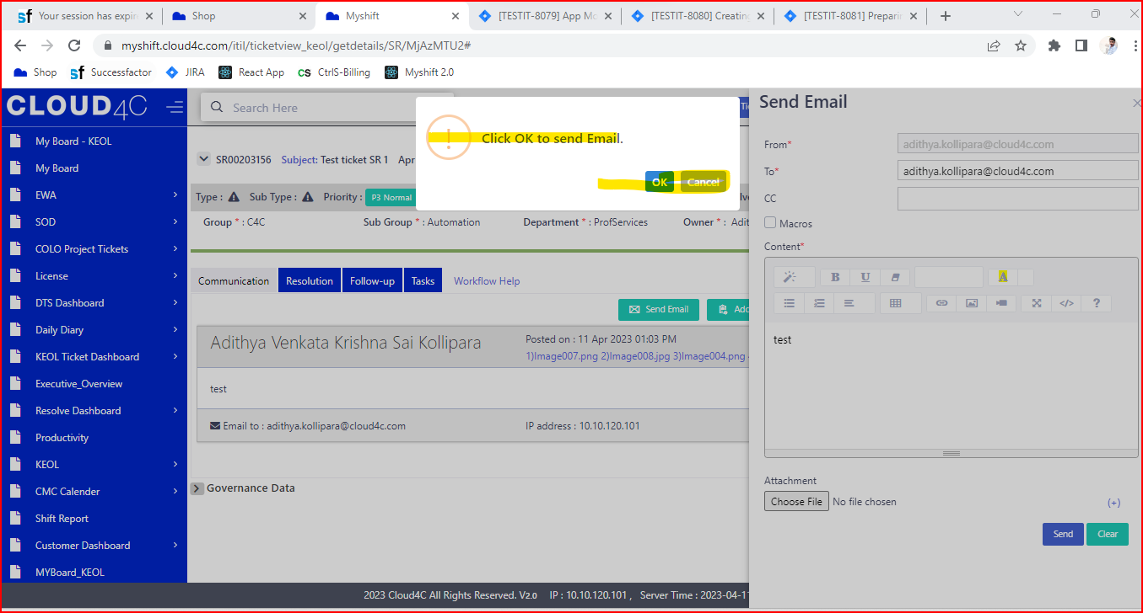

* By Clicking on the **OK** button in the confirmation POPUP, the email should be Send successfully.
* By Clicking on the **Cancel** Button the **EMAIL** should not be send.
* After sending the email the data should be store in the Communication tab as shown in the below screen shot.

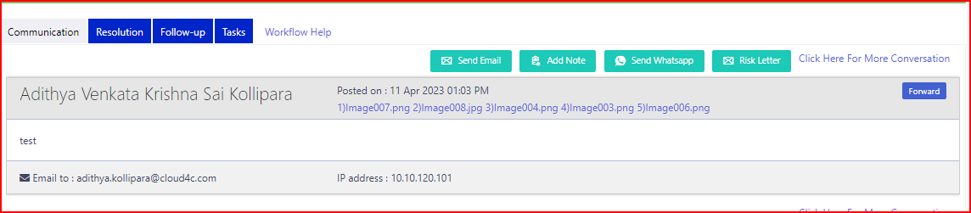

* In communication tab after sending the email Forward button should be display as shown in the below screen shot.

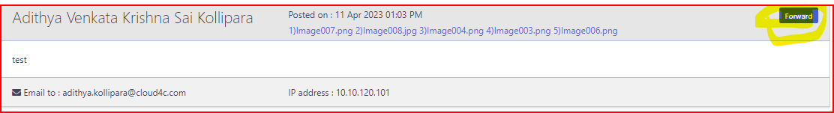

* By clicking on the **Forward button** the Send email tab will open as shown in the below screen shot.

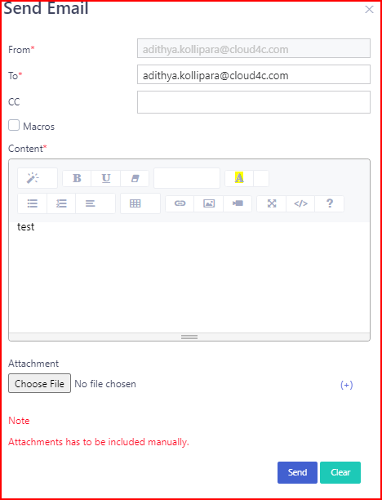

* By Clicking on the **ADD NOTE** button, the **ADD NOTE** tab should be display with bellow details as shown in the Below Screen shot.

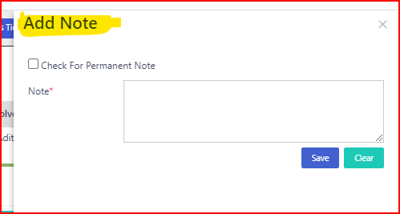

* In **ADD NOT**E tab, the details are **NOTE** with **Mandatory \*** symbol and Test box along with the SAVE and CLEAR buttons and **Check for Permanent** **Note** along with **CHECK BOX** as Shown in the Below Screen Shot.

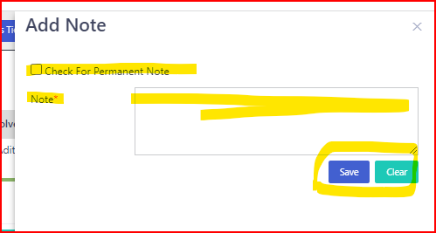

* After writing the NOTE click clear button, it should show the confirmation popup along with the OK and Cancel button as shown in the below scree shot.

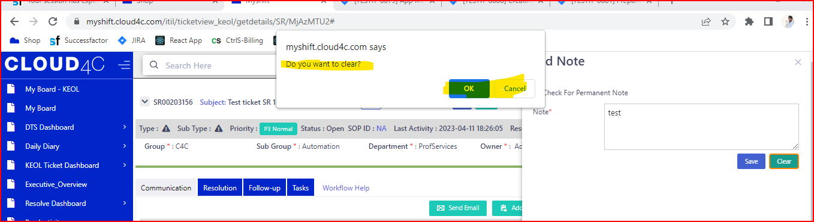

* By clicking on the **Cancel** Button in the **confirmation** popup the popup should be **cancel** and show the **Add** **Note** tab as shown in the below screen shot.

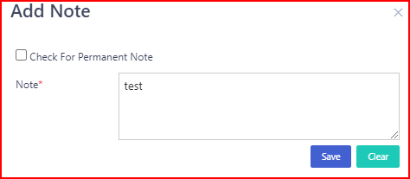

* By Clicking on the **OK** Button the Data Should be clear in the **ADD** **NOTE** tab as shown in the below screen shot.

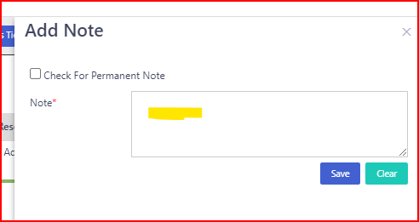

* By clicking on the Check box for permanent Note, the Note will be display permanently as shown in the below screen Shot.

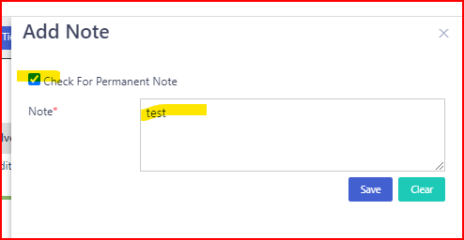

* By Clicking on the **SAVE** Button in **ADD** **NOTE** the Confirmation **POPUP** should be display along with **OK** and **CANCEL** button As Shown in the below screen shot.

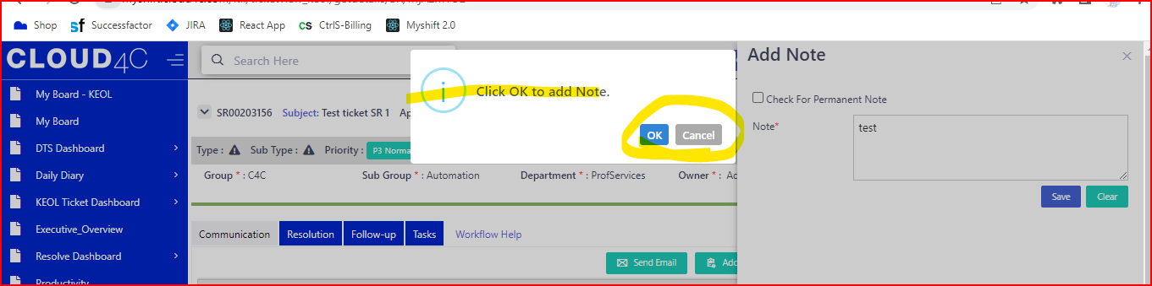

* By clicking on the Cancel Button in the confirmation popup the popup should be cancel and show the Add Note tab as shown in the below screen shot.

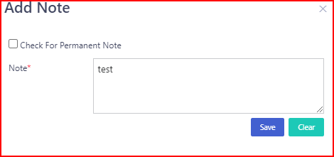

* By clicking on the **OK** button in the **SAVE** Confirmation popup the note should be save as shown in the below screen shot.

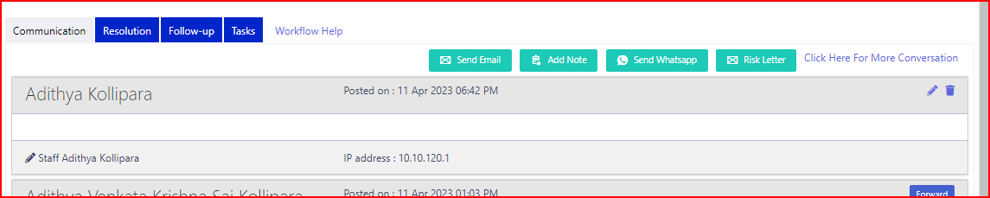

* The Below screen Shot shows that by clicking on the **Save** button in **ADD** **note** it was displaying in the Communication Tab.

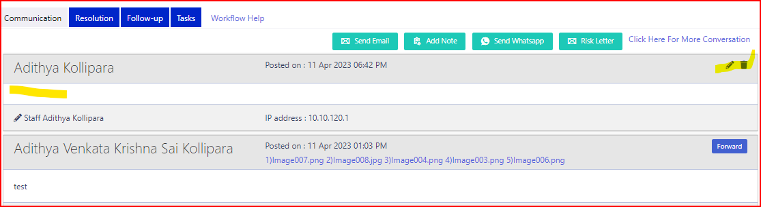

* In Communication Tab we have **Edit** icon and **Delete** icons as shown in the below screen shot.

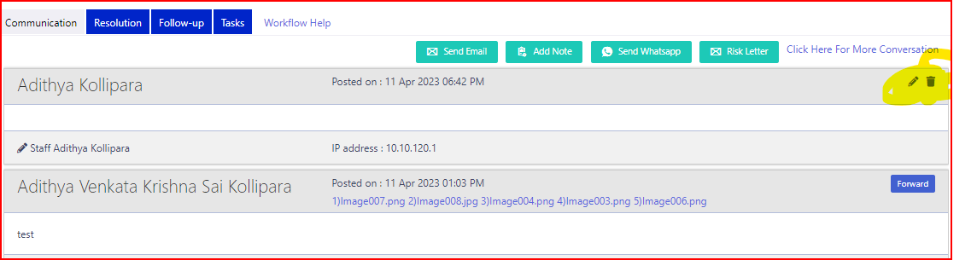

* By clicking on the **EDIT** icon In the Communication tab it should navigate to **ADD NOTE** tab with the details and **UPDATE** and clear buttons as shown in the Below screen shot

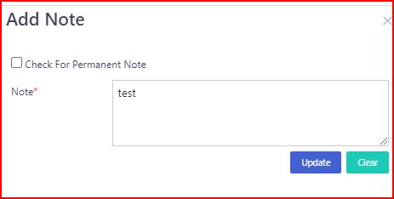

* By clicking on the **clear** button, it should show the confirmation popup along with the **OK** and Cancel button as shown in the below scree shot.

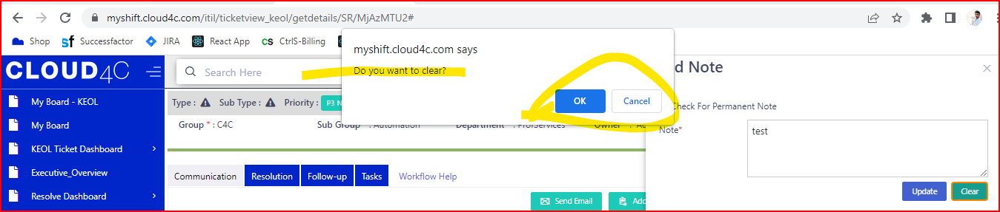

* By clicking on the **Cancel** Button in the **Clear** confirmation popup the popup should be cancel and show the Add Note tab as shown in the below screen shot.

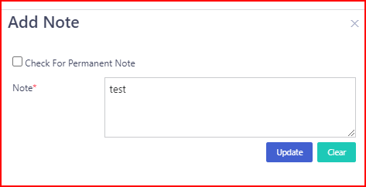

* By Clicking on the **UPDATE** Button In edit add note page, the confirmation popup should be display along with the **OK** and **CANCEL** buttons as shown in the Screen shot.

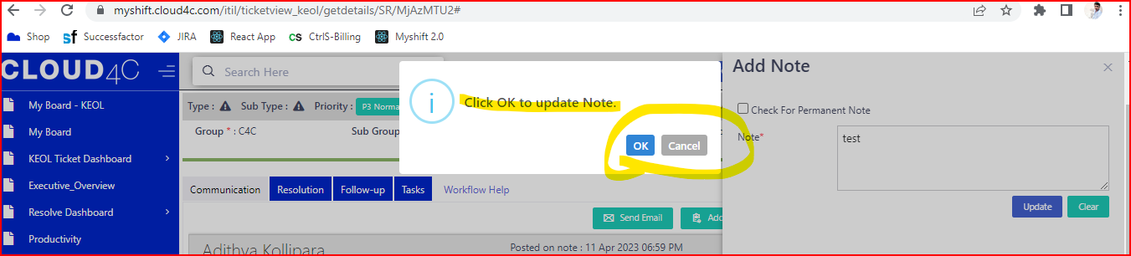

* By clicking on the **Cancel** Button in the confirmation popup the popup should be **cancel** and show the Add Note tab as shown in the below screen shot.



* By clicking on the **OK** button in the **UPDATE** Confirmation popup the note should be **UPDATE** successfully as shown in the below screen shot.



* By Clicking on the **DELETE** icon in the Communication tab for ADD note the confirmation popup should be display along with the OK and **CANCEL** buttons as shown in the below screen shot.

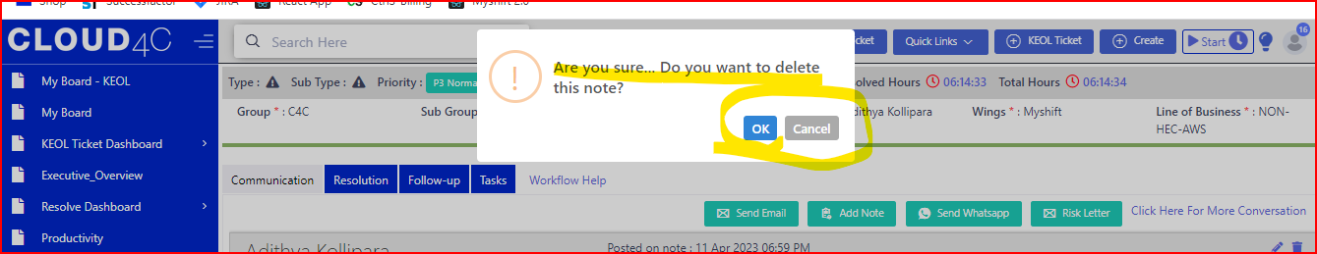

* By clicking on the **Cancel** Button in the delete confirmation popup, the popup should be cancel and show the Communication tab as shown in the below screen shot.



* By clicking on the **OK** button in the **DELETE** confirmation popup the Note should be deleted successfully.
* By clicking on the **SEND WHATSAPP** Tab/icon the **MESSAGE** Popup should be display as shown in the below screen shot.

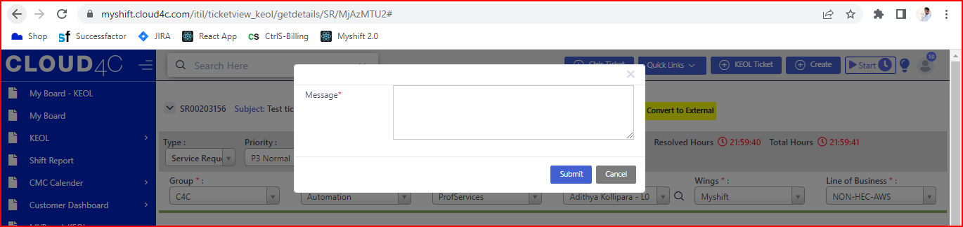

* In **WHATSUP** **MESSAGE** POPUP, message field along with the test box and SUBMIT and CANCEL buttons should be display as shown in the below screen shot.

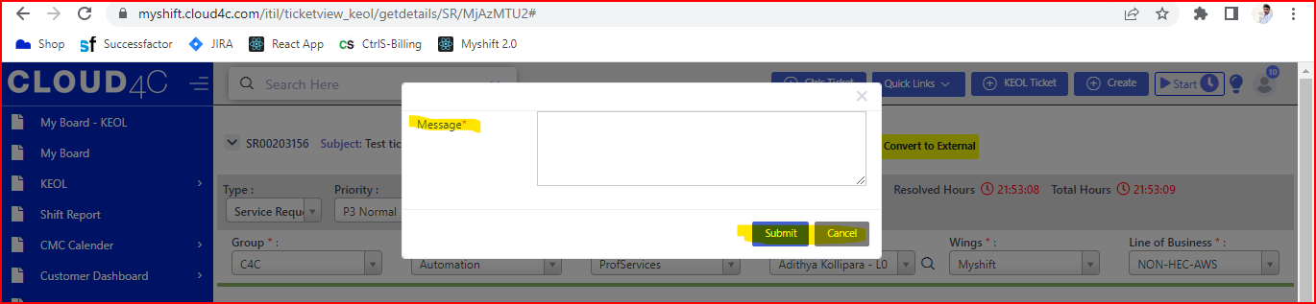

**NOTE:**  All the Fields are Mandatory with * symbol

* By clicking on the **SUBMIT** Button the Successful message should be display.
* By clicking on the **CANCEL** button the popup should be disappear.
* By clicking on the **RISK LETTER** tab, the RISK LETTER page should be display as shown in the below screen shot.

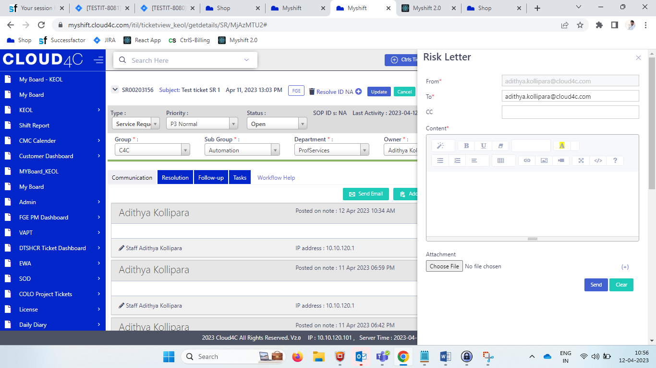

* In **RISK LETTER**  tab the below details like **FROM, TO, CC, CONTENT, ATTACHMENT** with **CHOOSE FILE BUTTON, SEND AND CLEAR** buttons should be display as shown in the below screen shot.

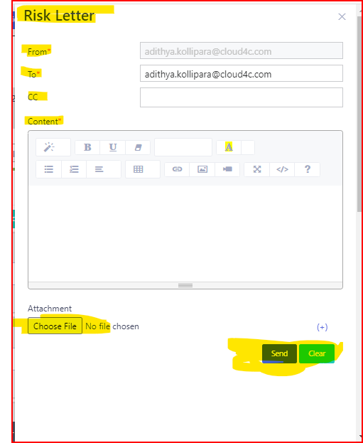

* In the **RISK LETTER** tab, **FROM** field should have the test box with protected mode and it should be display as shown in the below screen shot.

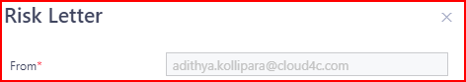

* In the **RISK LETTER** tab, **TO** field should have the test box with editable mode and it should be display as shown in the below screen shot.

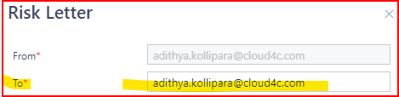

* In the **RISK LETTER** tab, **CC** and **Content** field should have the test box with editable mode and it should be display as shown in the below screen shot.

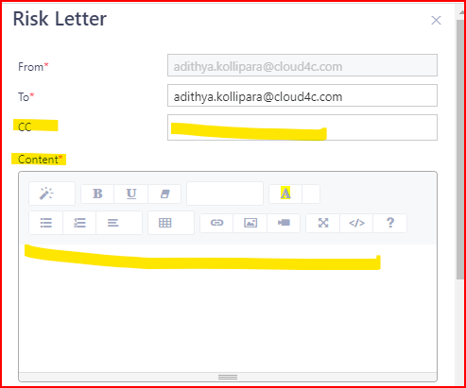

* In CONTENT field all the types of details like **FONT, STYLE, FORMATS, and ATTACHMENT ICONS** etc.., Should be display as shown in the above screen shot.
* In **RISK LETTER** the ATTACHMENT should be display along with the choose file button with no file chosen message and PLUS (+) symbol as shown in the below screen shot.

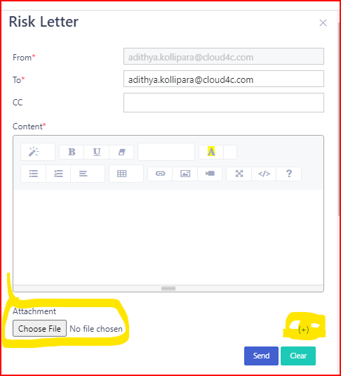

* By clicking on the **PLUS (+)** button the another choose file buttons should be display along with the **CLOSE/CANCEL (X)** Symbol as shown in the below screen shot.

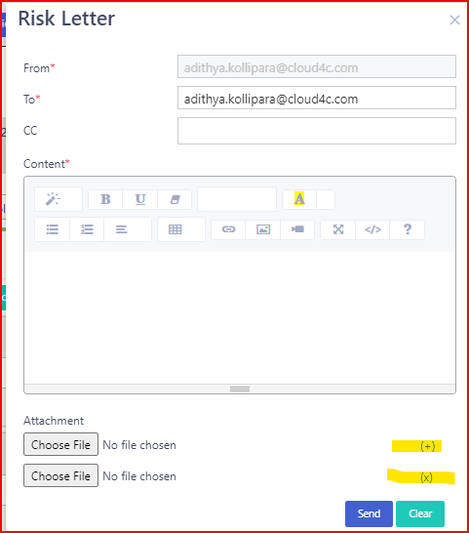

* By clicking on the **CLEAR** button the CLEAR confirmation POPUP should be display as shown in the below screen shot.

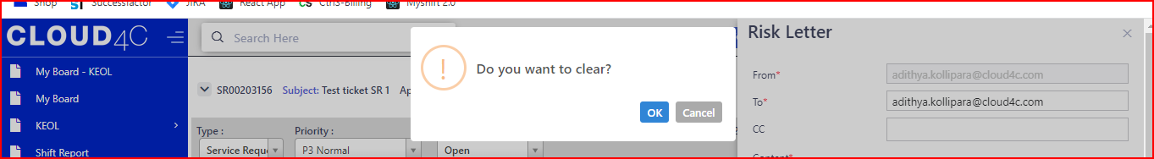

* In **Clear** confirmation pop up, **OK** and **CANCEL** buttons should be display as shown in the below screen shot.

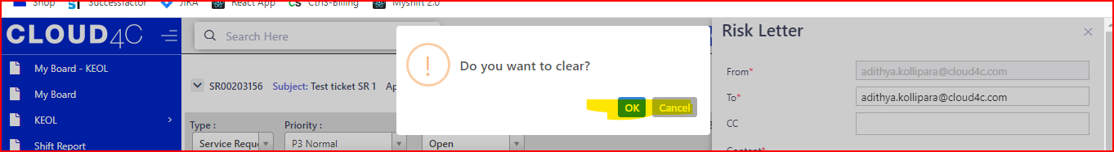

* In **Clear** Confirmation popup, by clicking on **CANCEL** button the popup should be closed.
* In **Clear** Confirmation popup, by clicking on **OK** button the data should be clear.
* By clicking on the **SEND** button in the **RISK** **LETTER** the **SEND** confirmation popup should be display as shown in the below screen shot.

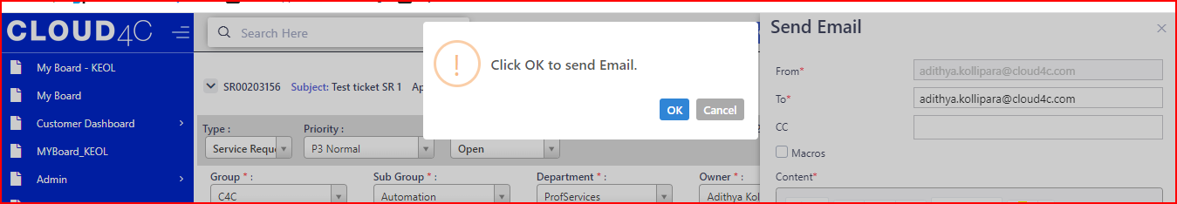

* In **SEND** Confirmation popup the **OK** and **Cancel** buttons should be display as shown in the above screen shot.
* By clicking on the **OK** button the **RISK LETTER** should be submitted.
* By clicking on the **CANCEL** button the **RISK LETTER** should be cancel.

**RESOLUTION TAB:**

* The Resolution tab will be display as shown in the below screen shot

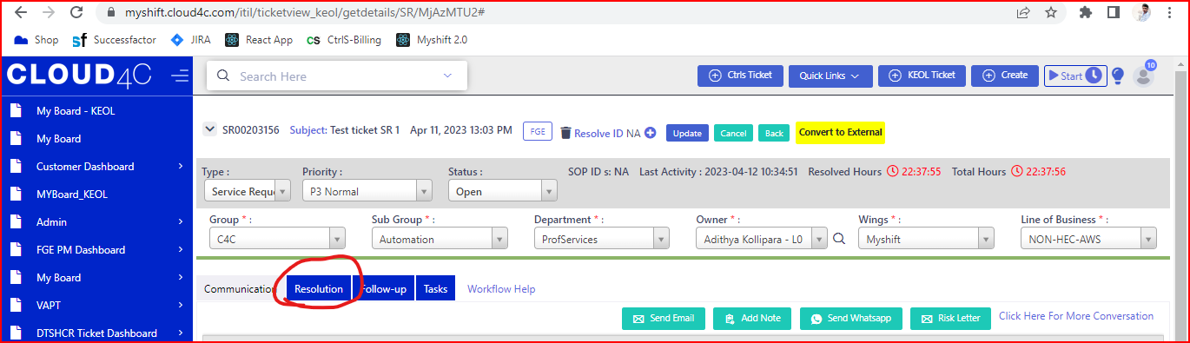

* By clicking on the **RESOLUTION** Tab the page should be display as shown in the below screen shot.

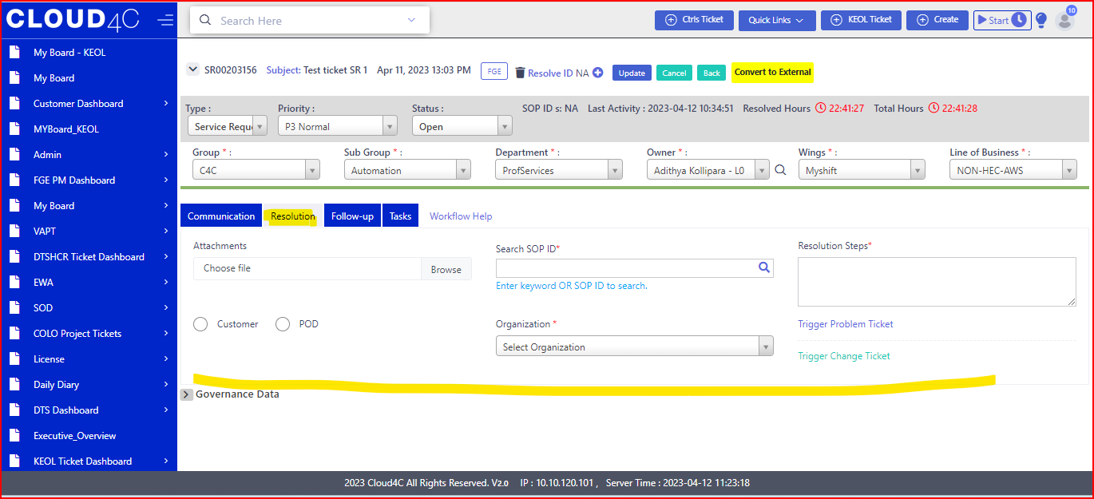

* In **RESOLUTION** tab the below details like Attachment with choose file field with BROWSE button, **CUSTOMER** and **POD** radio buttons, Search SOP ID with Search field, Organization with dropdown, resolution steps with test box, Trigger problem ticket link and trigger change ticket link should be display as shown in the below screen shot.

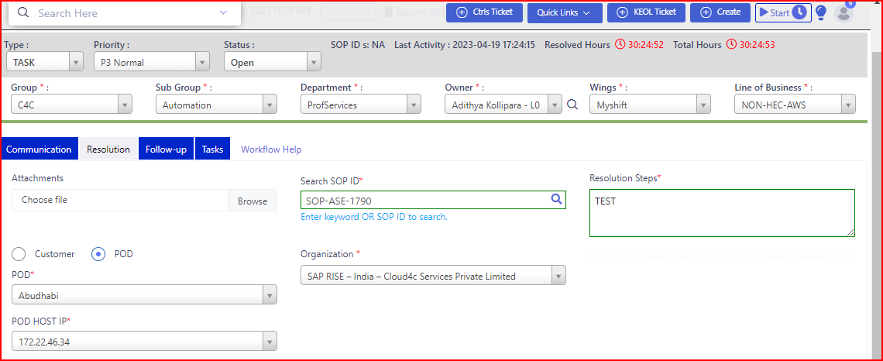

NOTE: All the fields should be mandatory with * symbol except attachments.

* By selecting the **CUSTOMER** radio button the **SID** field with dropdown should be display as shown in the below screen shot.

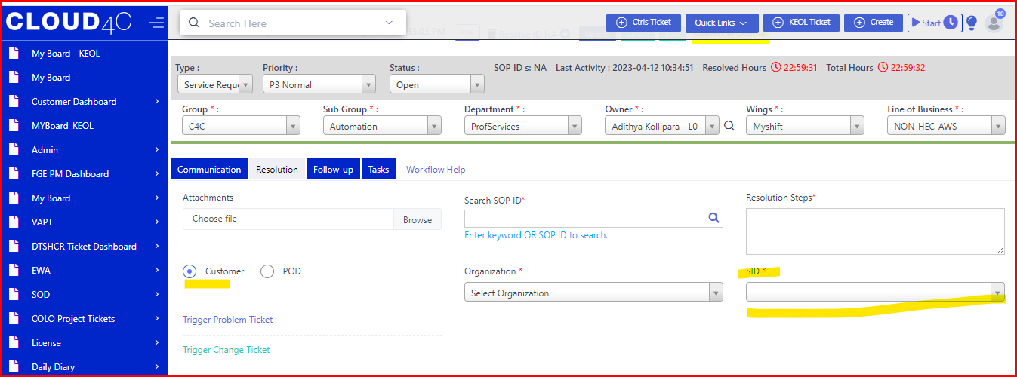

* By selecting the **POD** radio button the **POD HOST, POD HOST IP** fields along with the dropdown should be display as shown in the below screen shot.

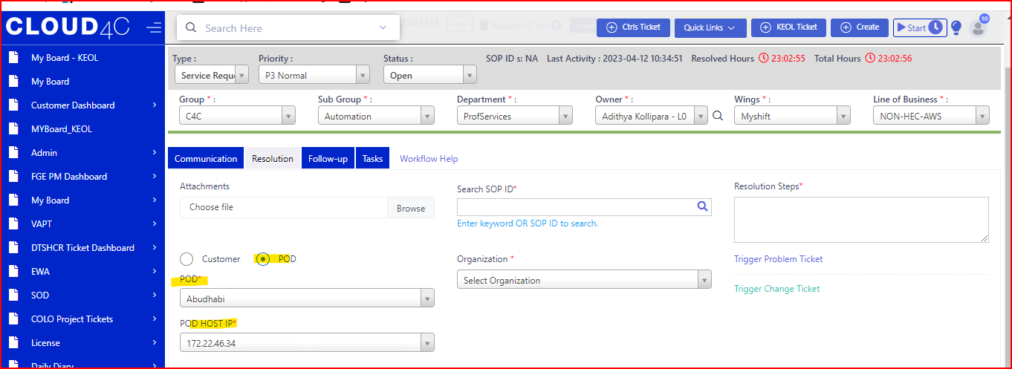

* By entering the data in to the Search SOP ID and click on the Search icon, the SOP ID list should be display as shown in the below screen shot.

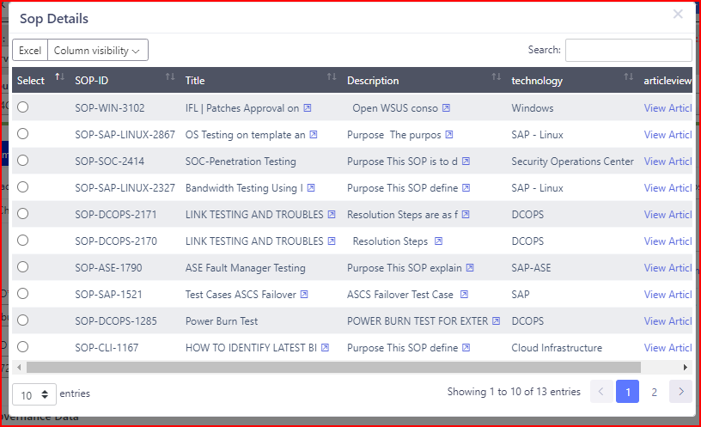

* By clicking on the Organization dropdown the list should be display as shown in the below screenshot.

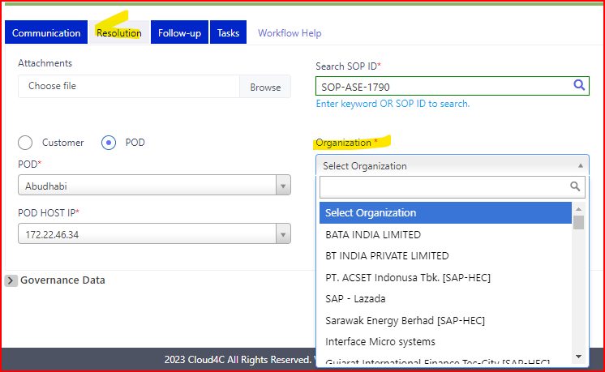

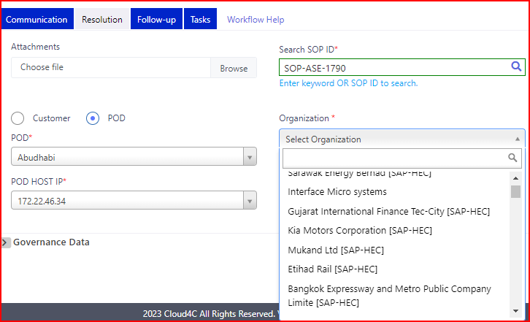

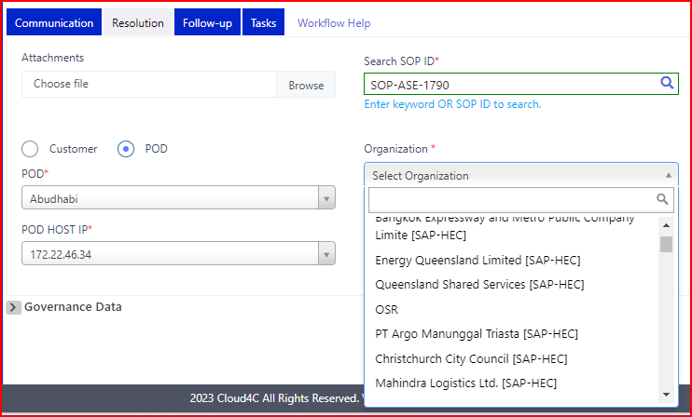

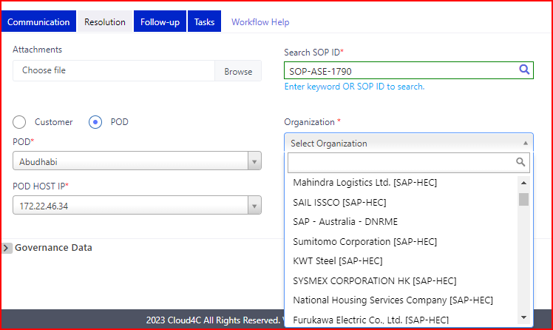

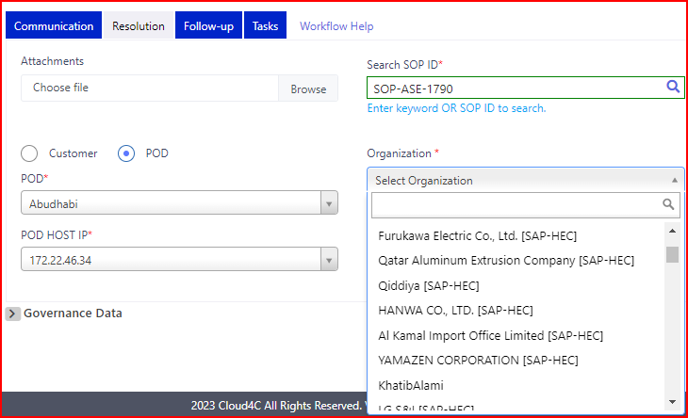

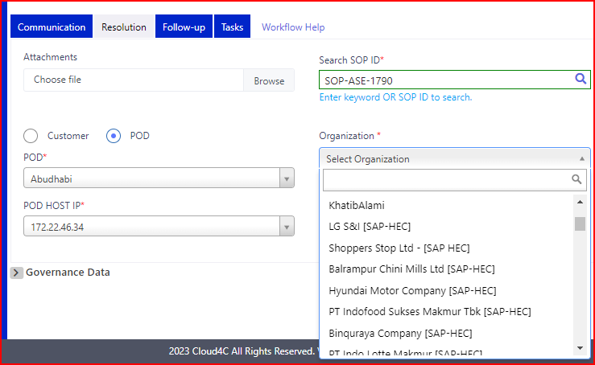

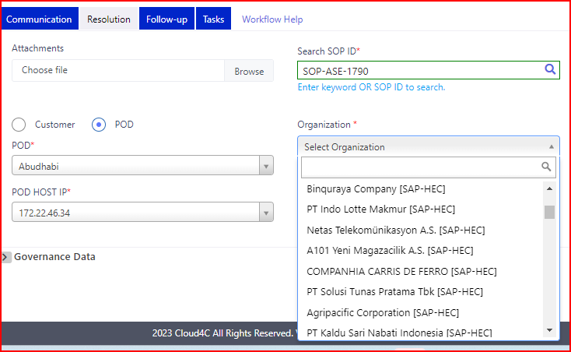

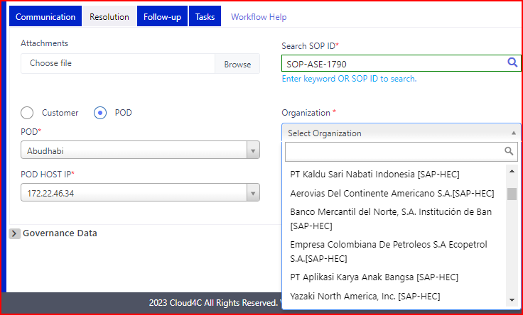

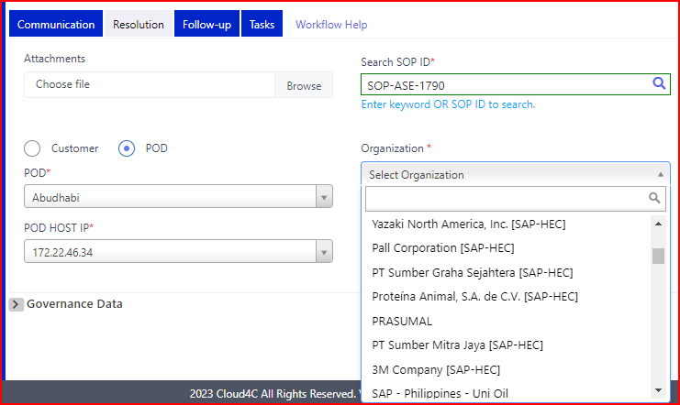

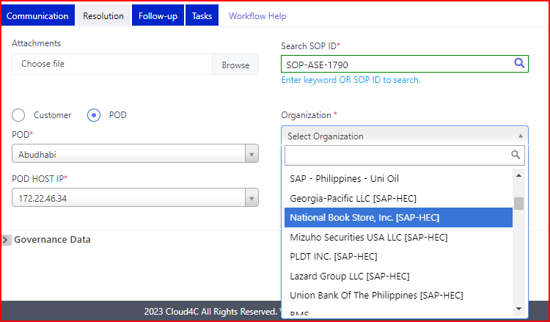

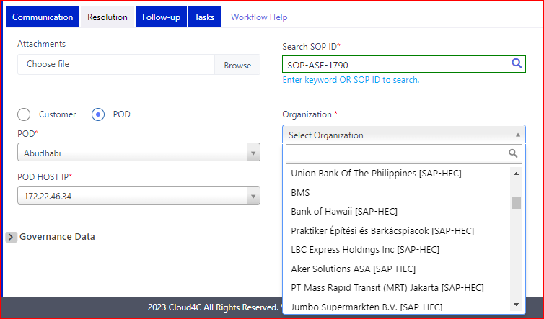

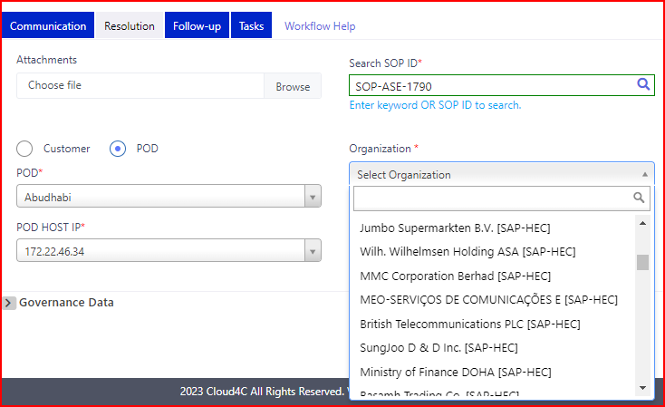

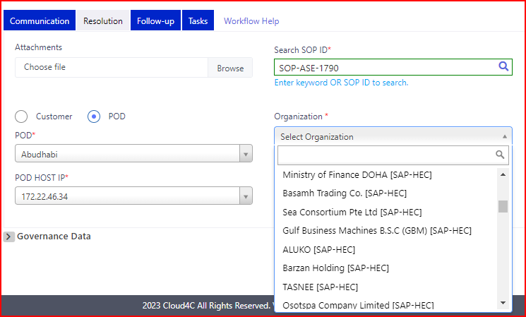

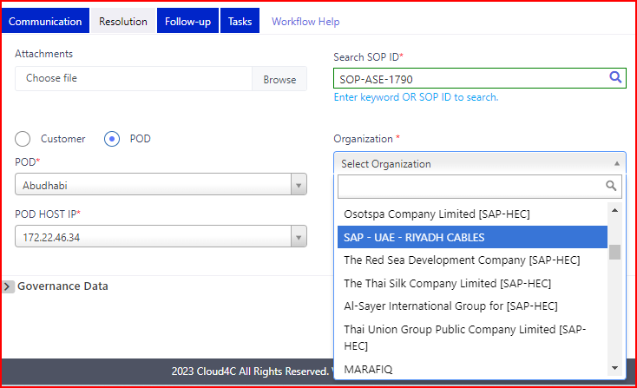

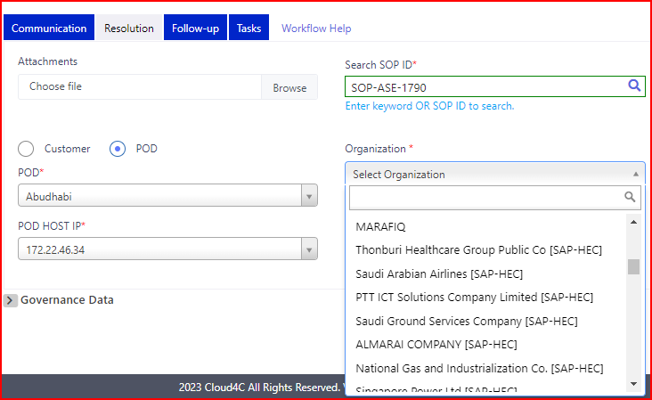

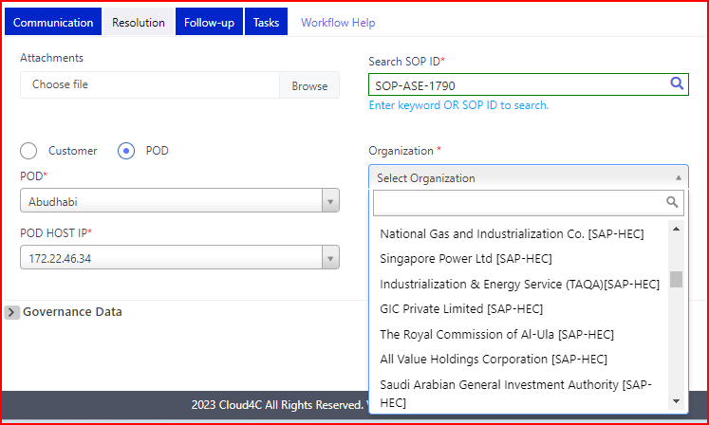

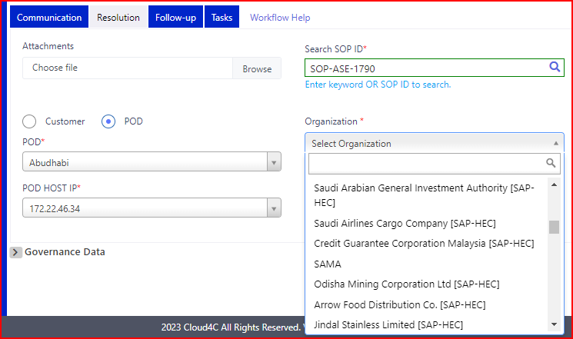

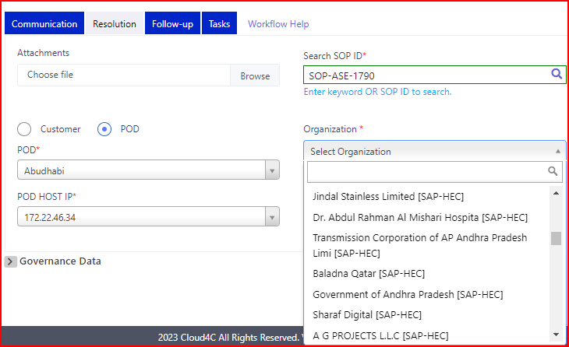

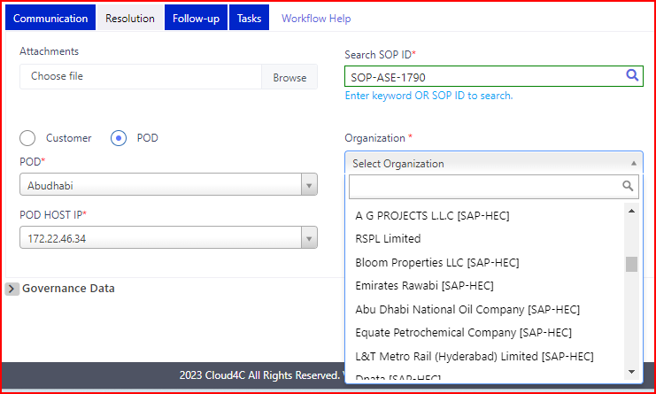

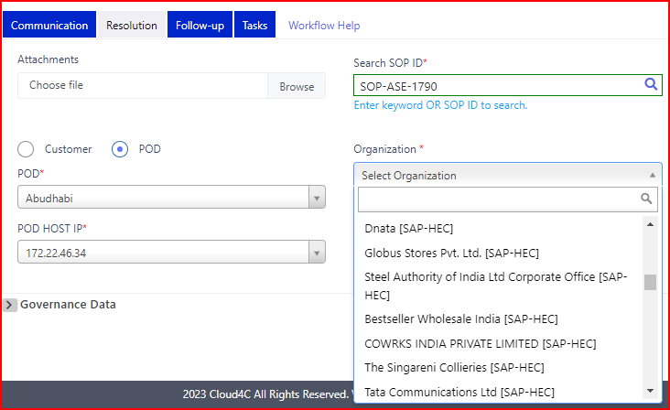

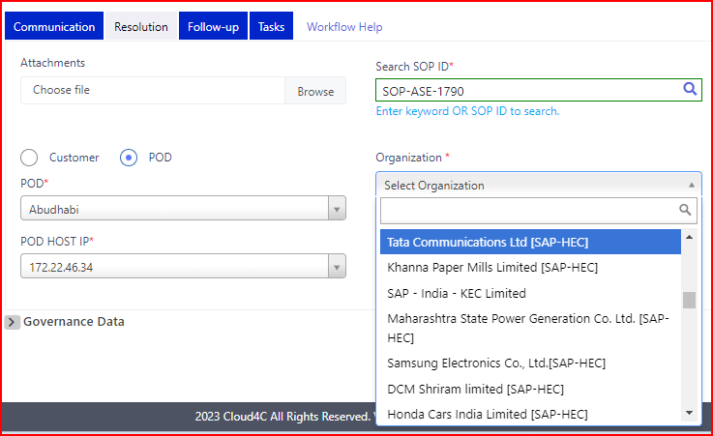

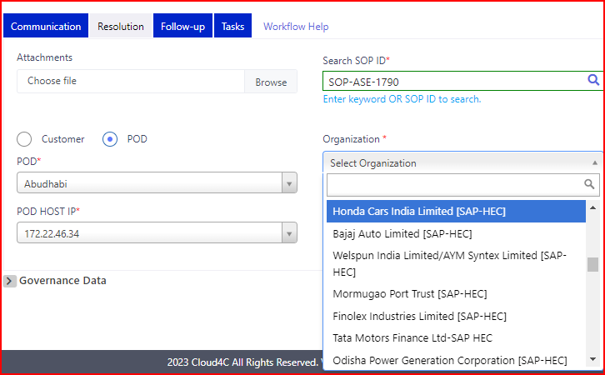

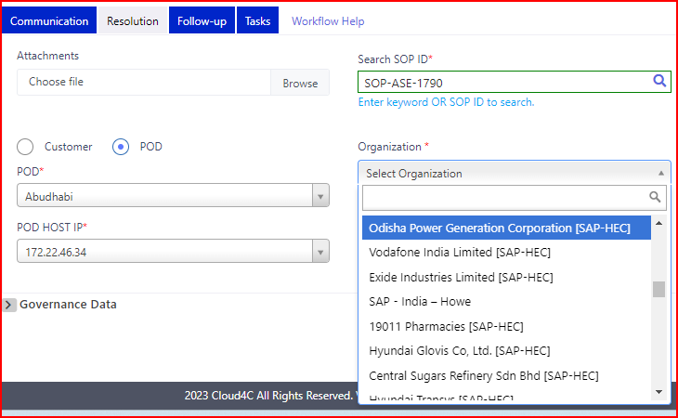

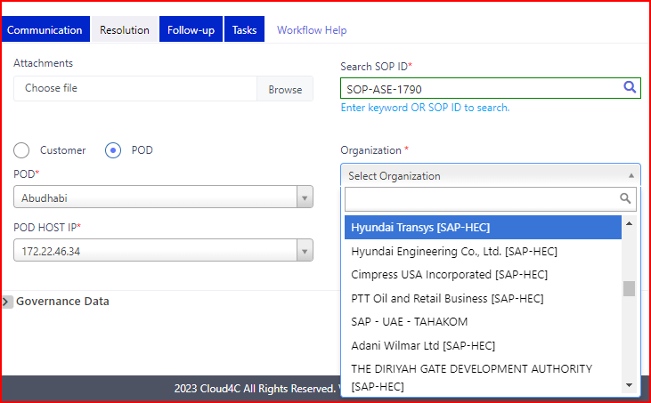

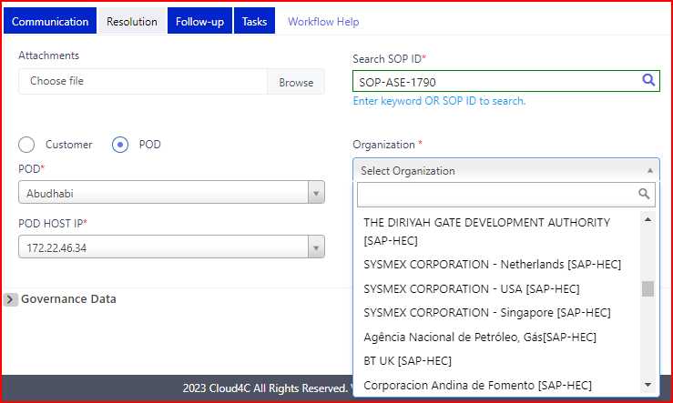

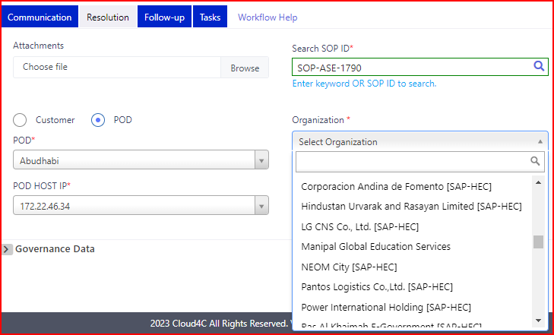

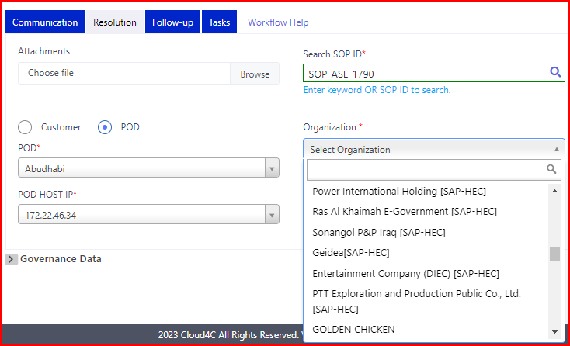

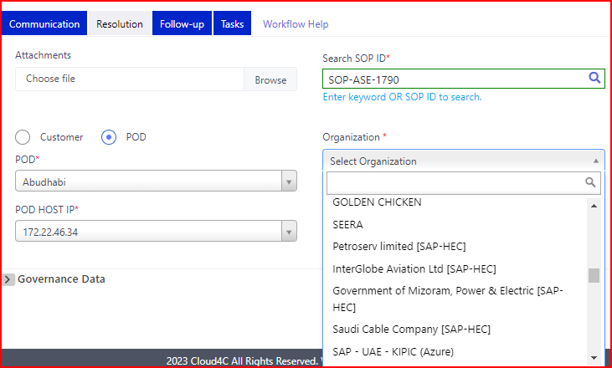

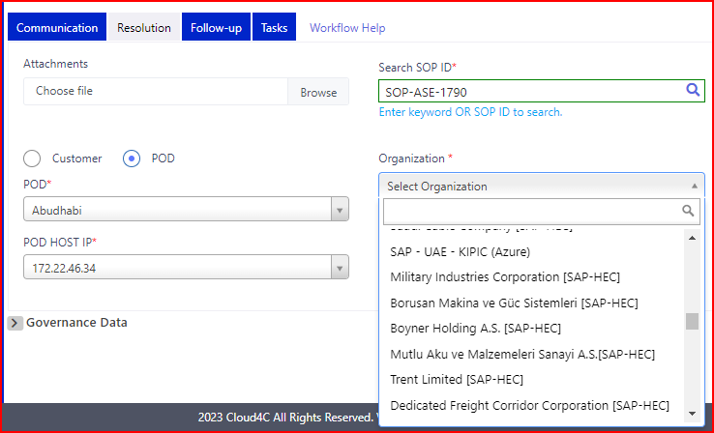

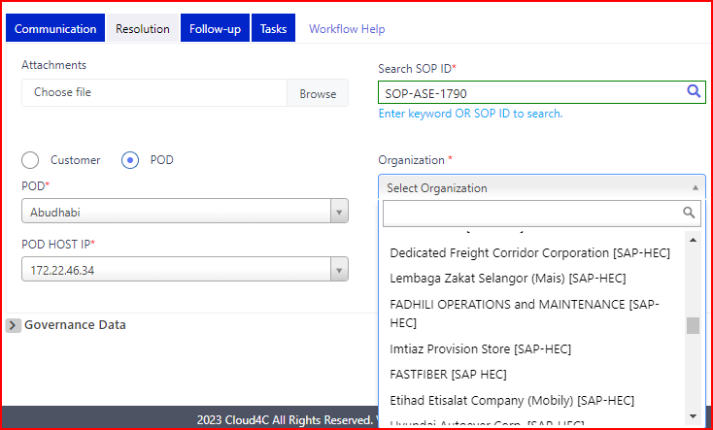

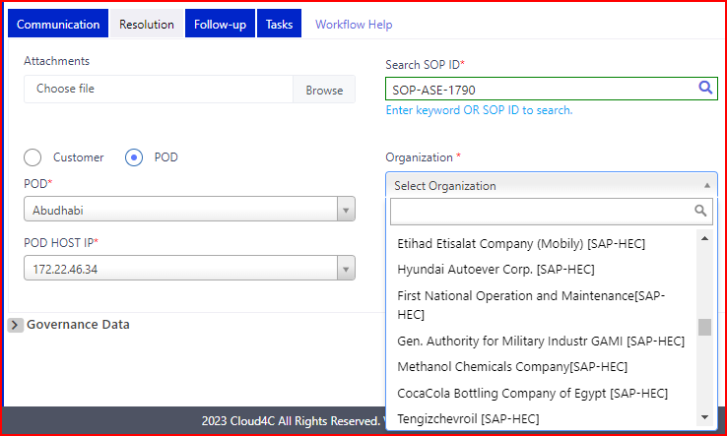

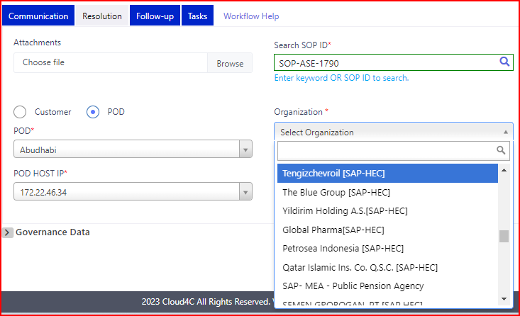

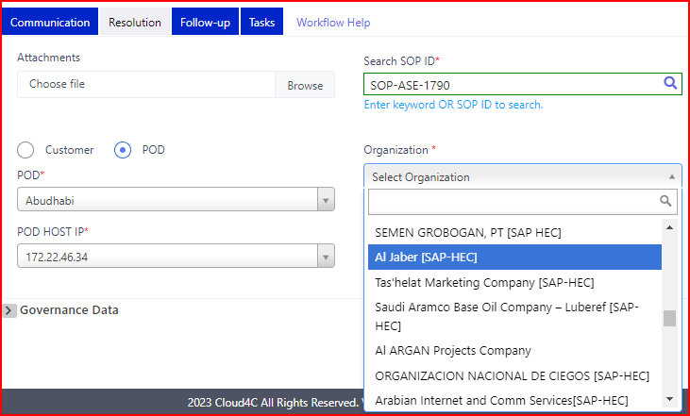

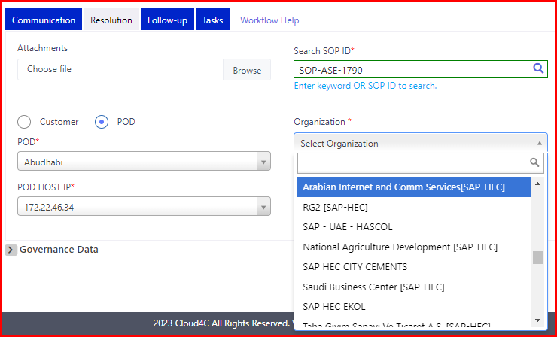

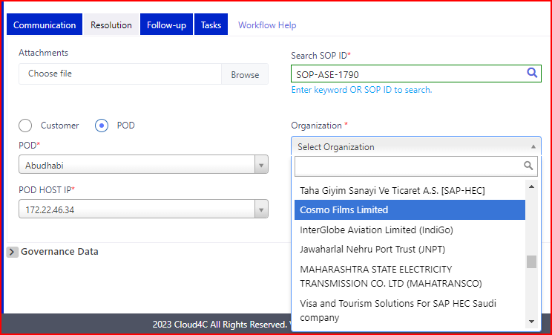

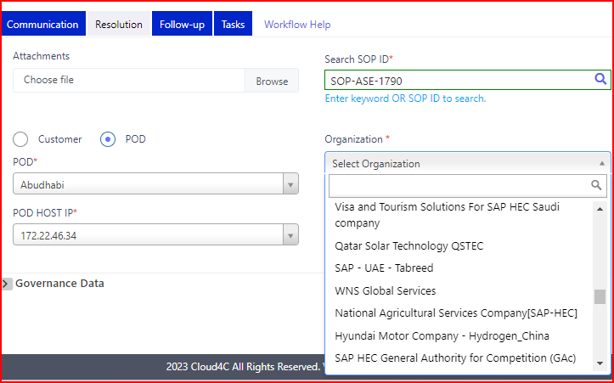

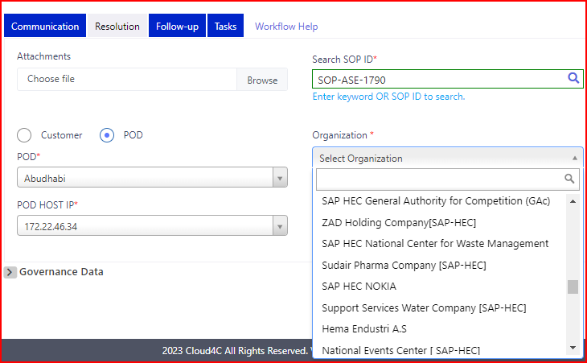

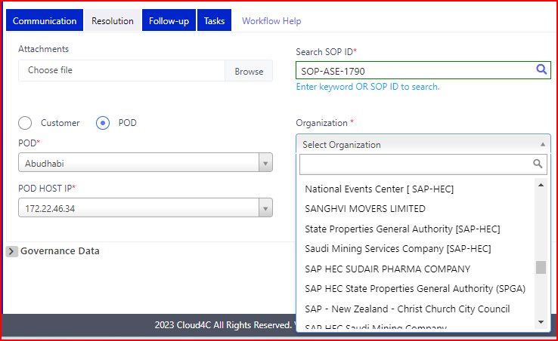

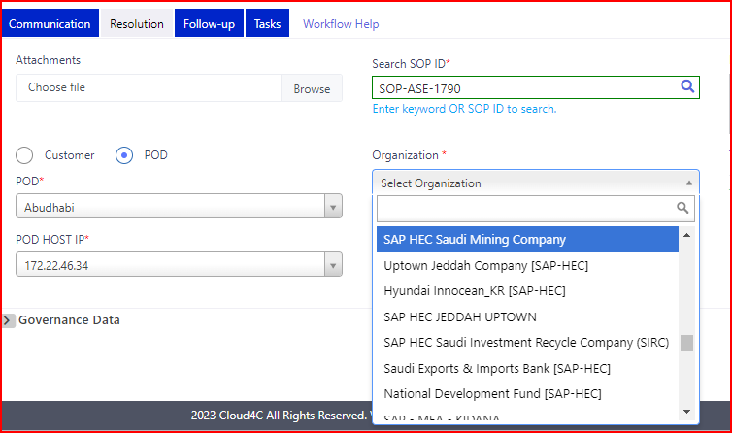

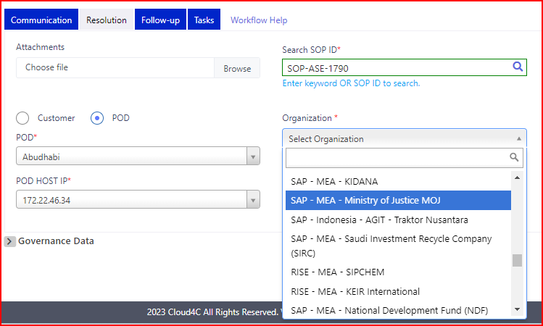

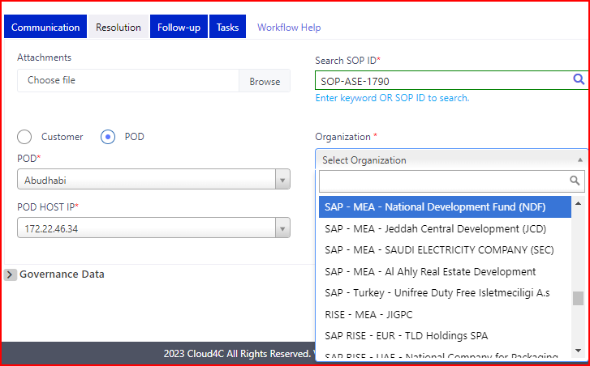

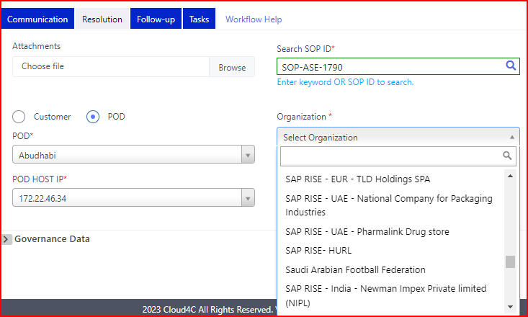

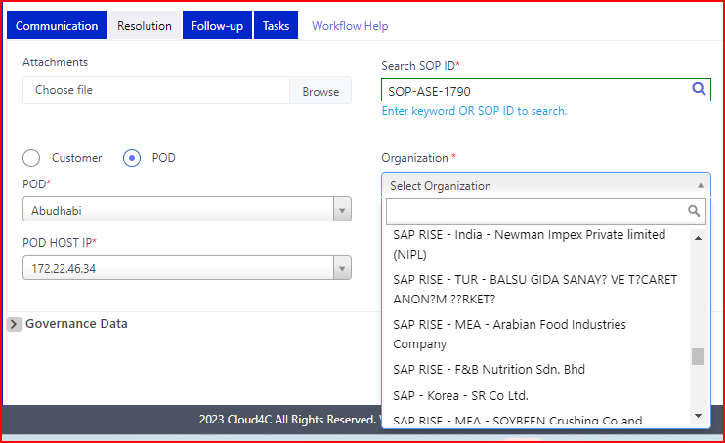

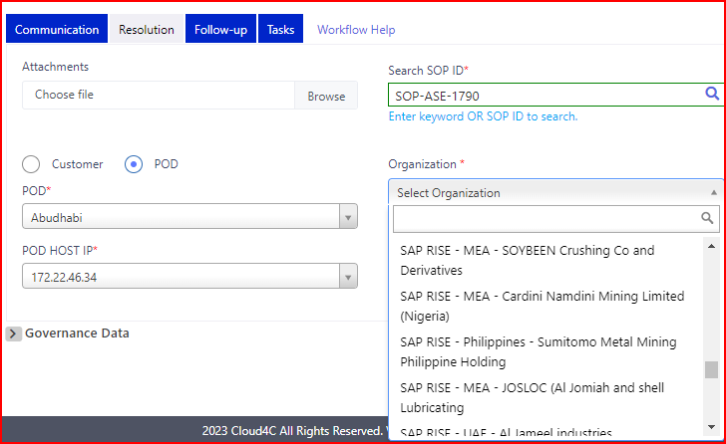

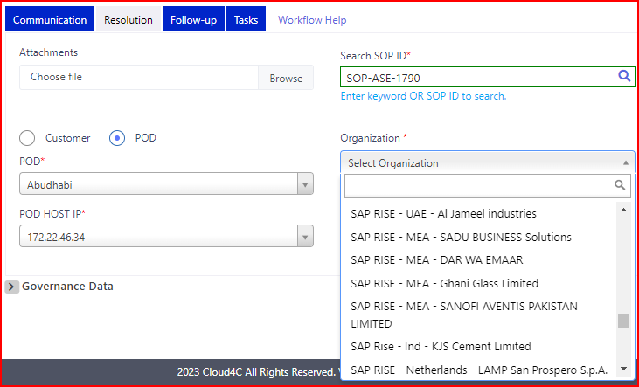

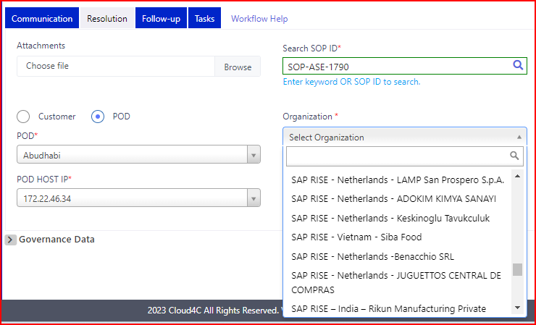

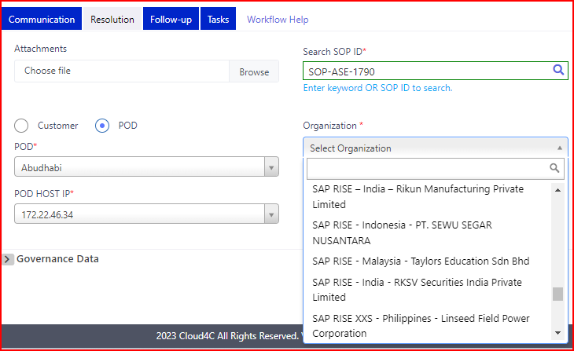

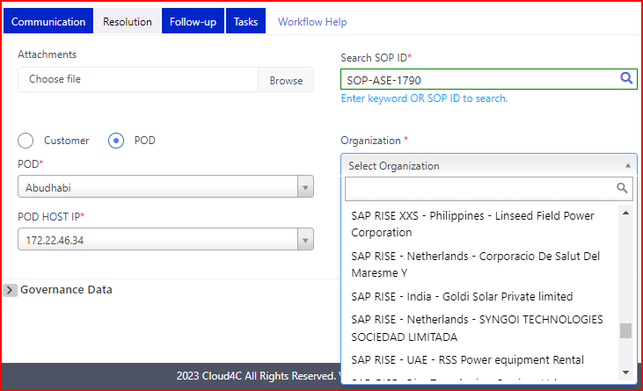 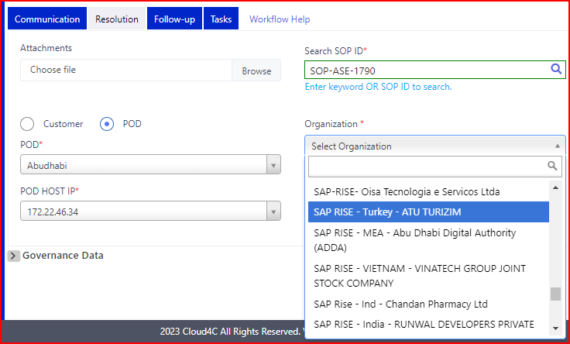

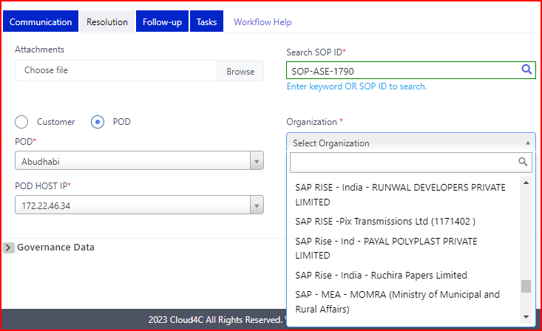

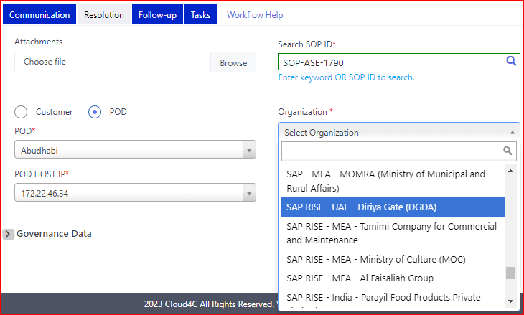

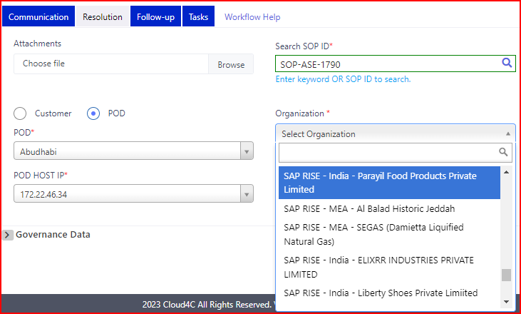

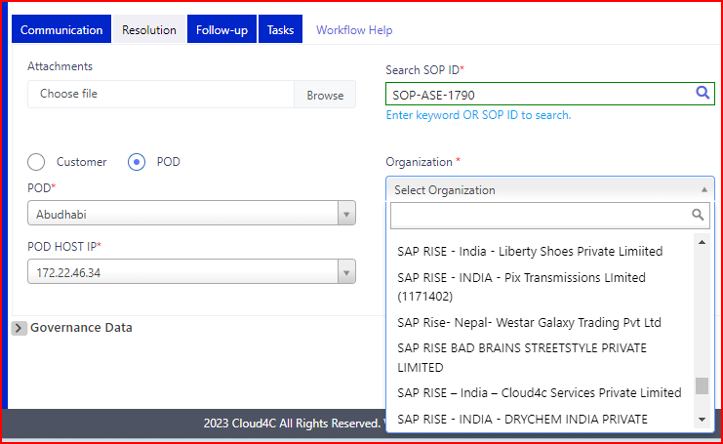

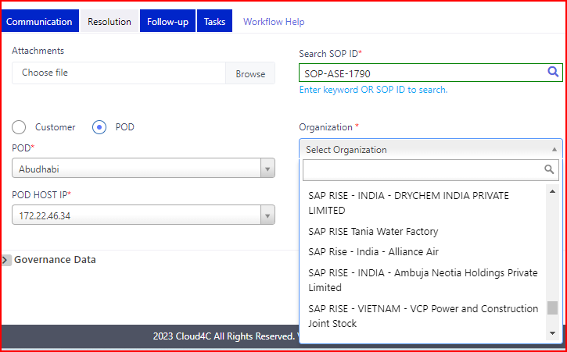

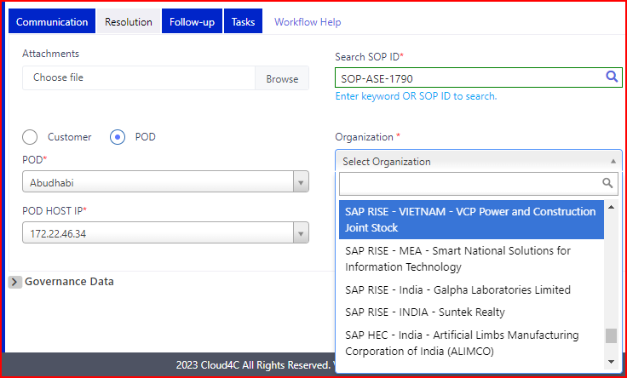

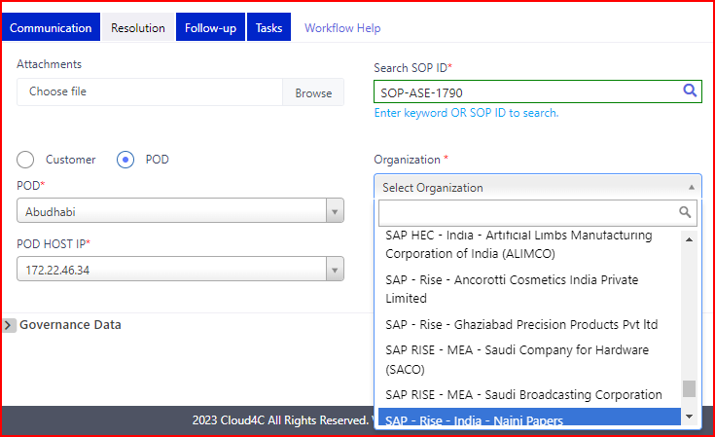

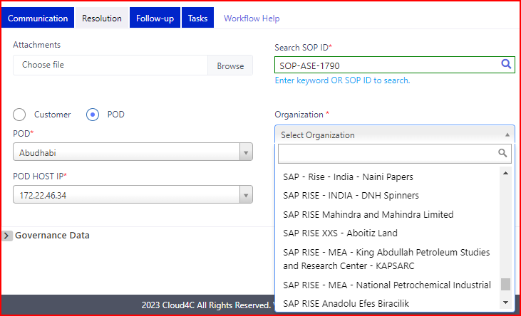

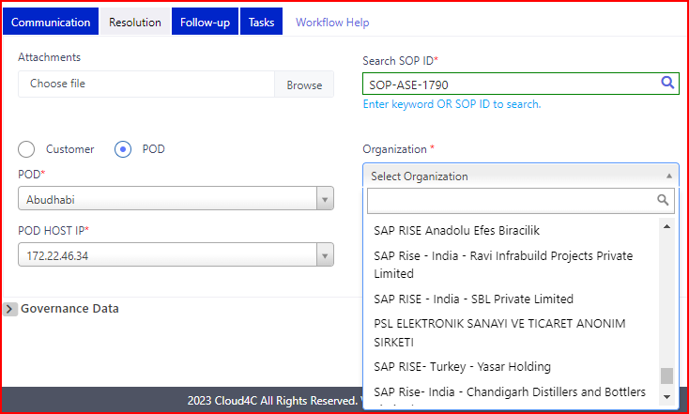

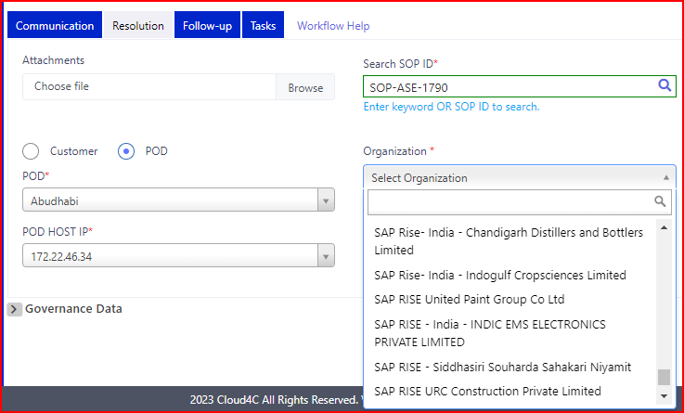

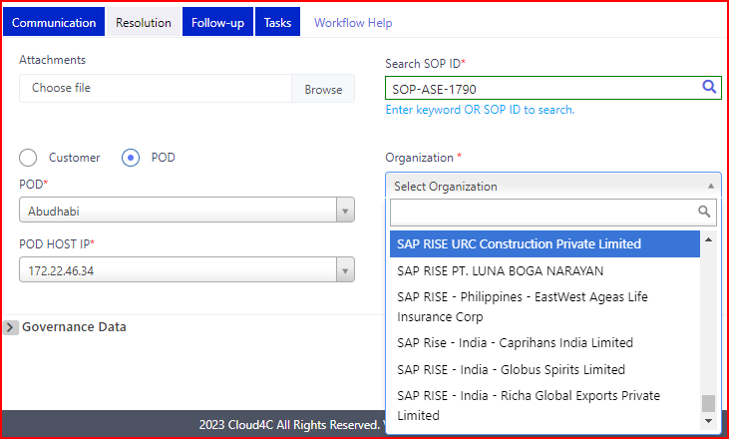

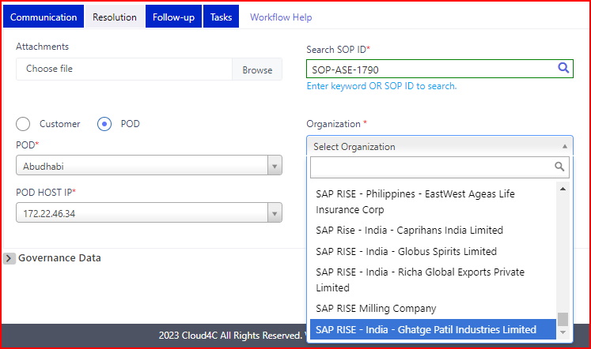

* By clicking on **Trigger Problem** ticket link the ticket creation page should be display as shown in the below screen shot.

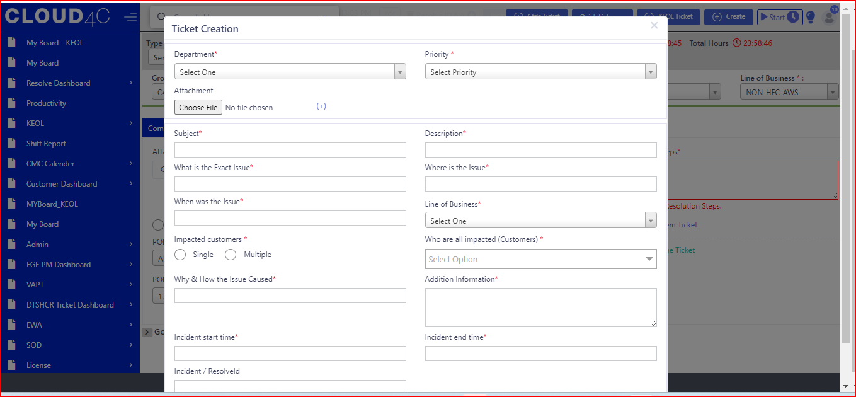

* By clicking the **trigger problem ticket** link the highlighted fields should be display as shown in the below screen shot.

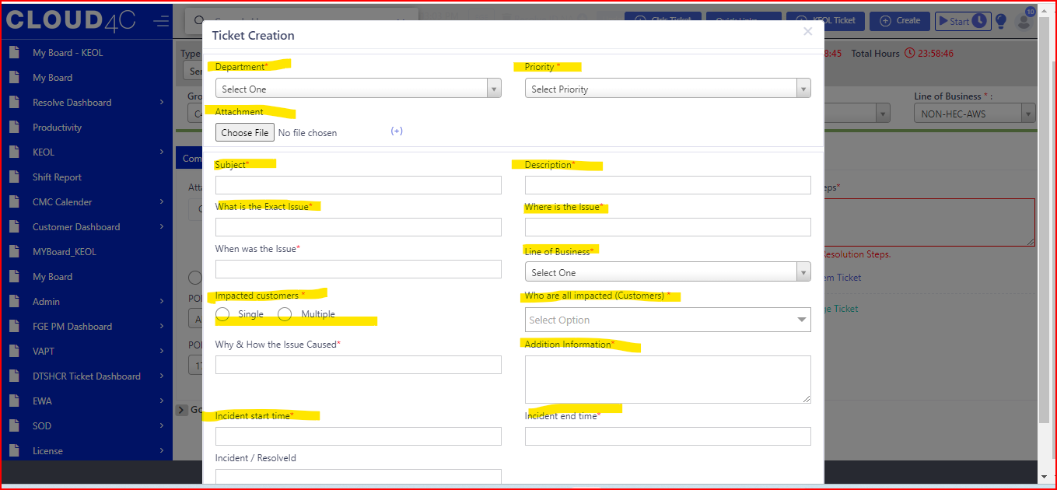

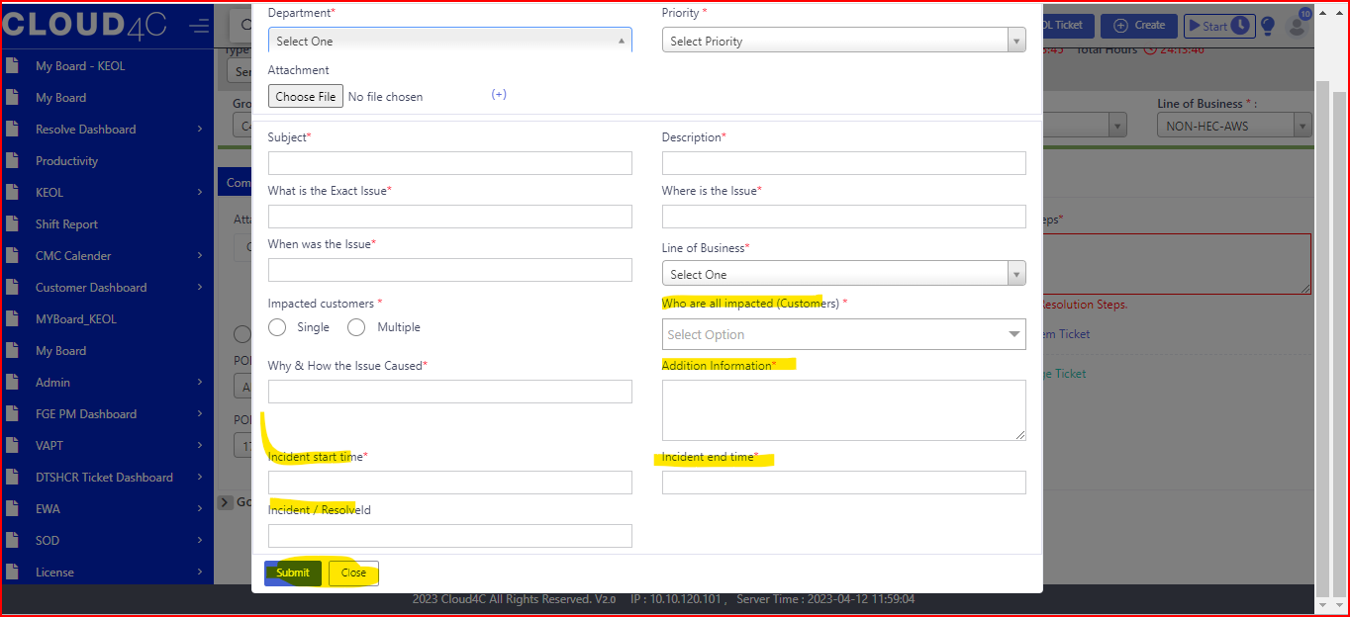

* By clicking on the TRIGGER CHANGE TICKET, the New CR-SAP ticket details page should be open as shown in the below screen shot.

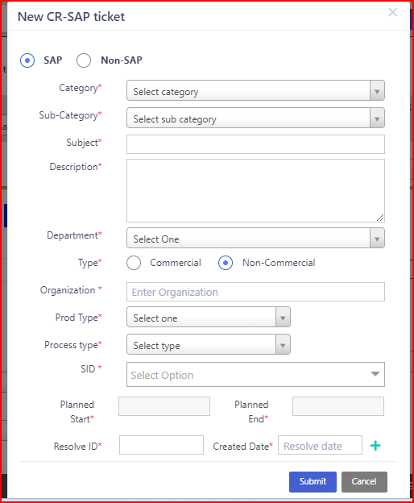

* By clicking on the TRIGGER CHANGE TICKET link, in the New CR-SAP ticket page the highlighted fields should be display as shown in the below screen shot.

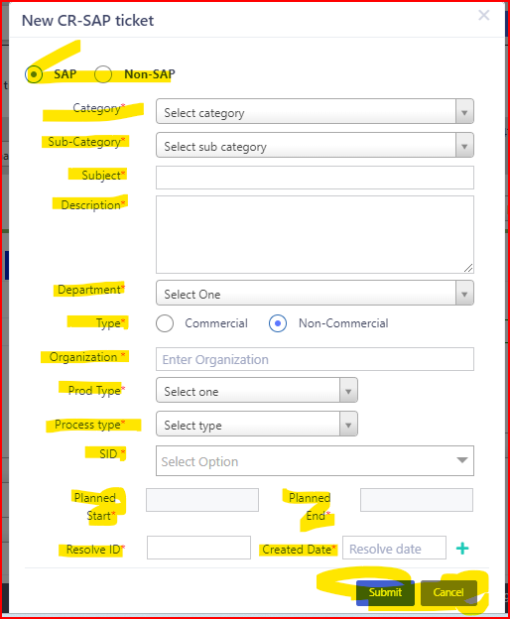 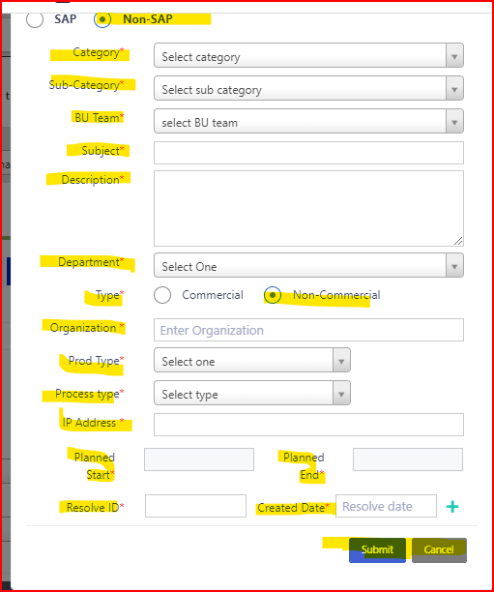

* In SAP and NON SAP radio button by selecting the Commercial radio button the below highlighted field (please select opf number) should be display as shown in the below screen shot.

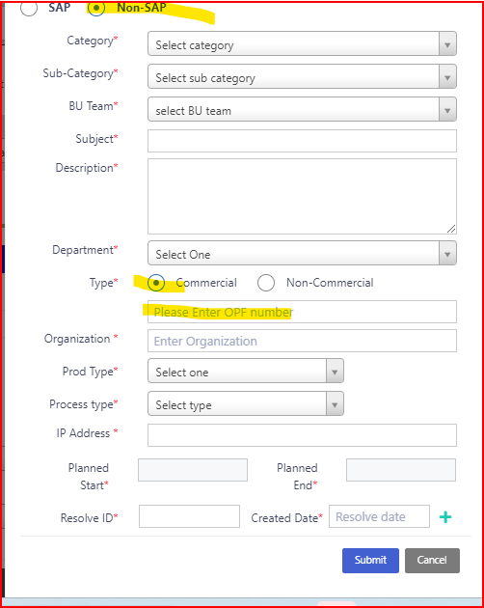

* NOTE: before selecting the Follow up tab the status should be in ACTIVITY condition.
* Change the status from **OPEN to ACTIVITY** AS shown in the below screen shot.

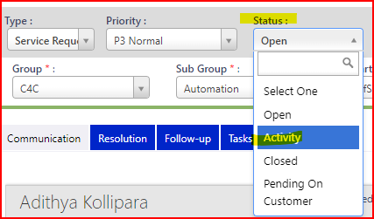

* By selecting the ACTIVITY in the Status, the Details widow will be display as shown in the below screen shot.

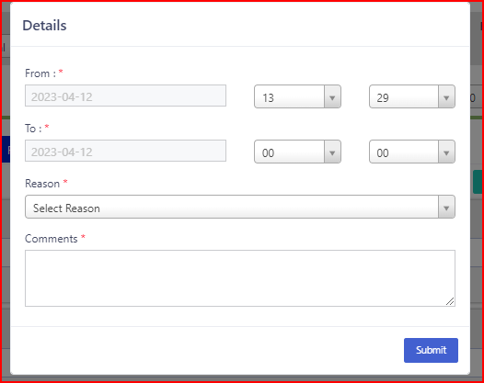

* Select the FROM and TO dates along with reason and comments click on the submit button.
* By selecting the Reason the details should be display in the Drop down as shown in the below screen shot.

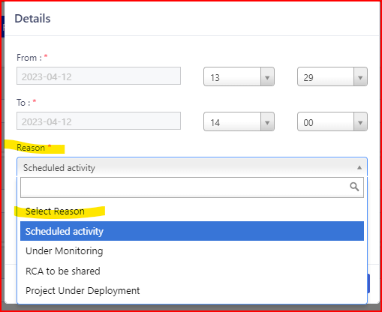

* By clicking on the Submit button the Confirmation popup should be display as shown in the below screen shot.

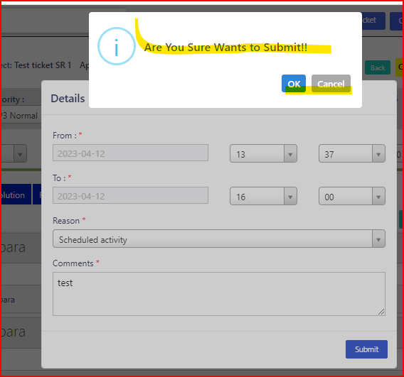

* By clicking on the OK button in the Confirmation popup the Activity details should be Submitted Successfully and click on UPDATE button.
* By clicking on the UPDATE button, the confirmation popup should be display and the page should be redirect it should display as shown in the below screen shot.

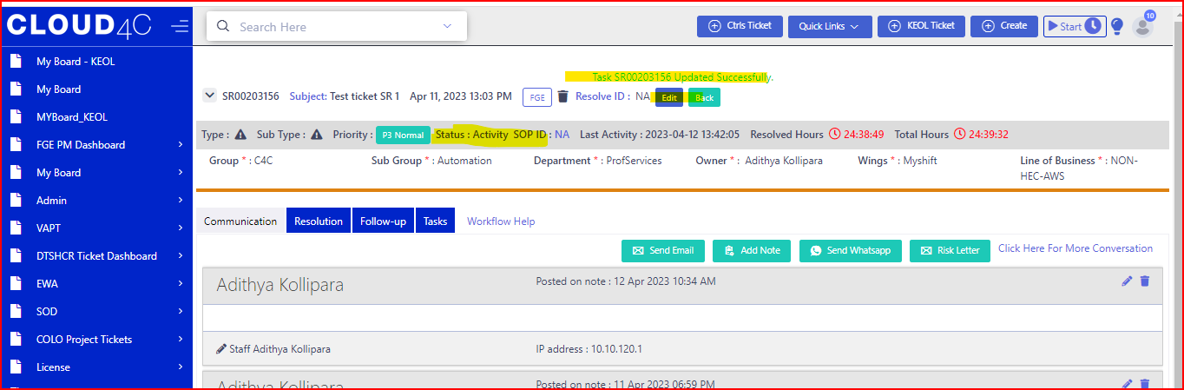

**FOLLOWUP:**

* By clicking on the Follow up tab, the page should be display as shown in the below screen shot.

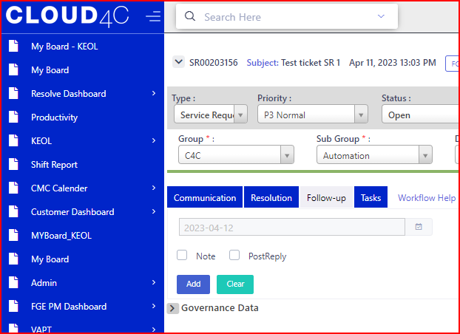

* In the Follow up tab the below highlighted fields should be display as shown in the below screen shot

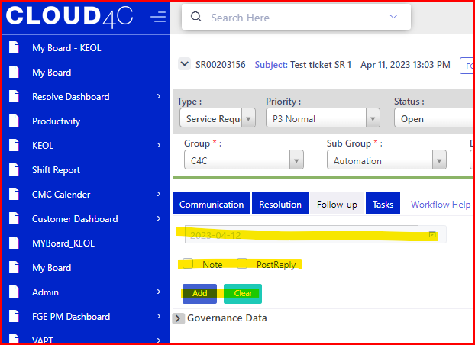

* By clicking on the Calendar icon the calendar should be display as shown in the below screen shot.

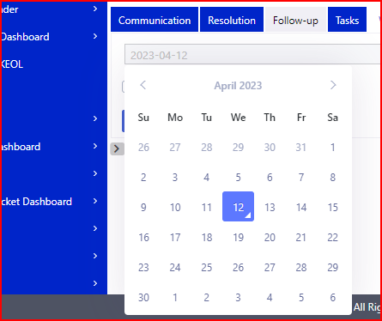

* By clicking on the NOTE check box, the ADD NOTE tab should be display as shown in the below screen shot.

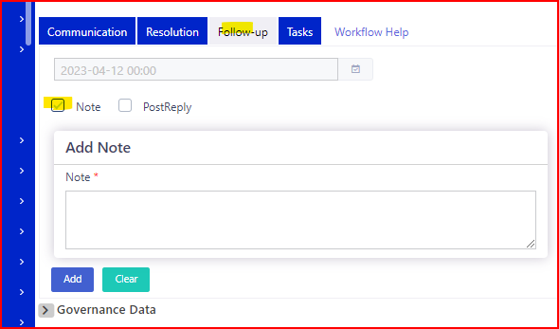

* By clicking on the POST REPLAY icon, the POST REPLY tab should be display as shown in the below screen shot.

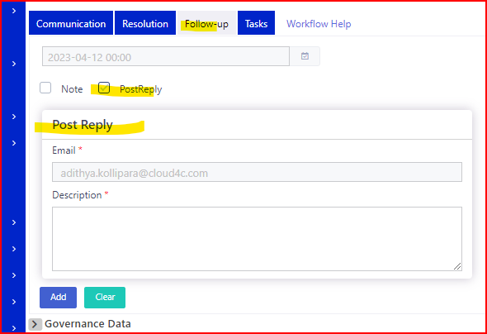

* By clicking on the ADD Button in the both NOTE and POST REPLAY, the below pop should be display as shown in the screen shot.

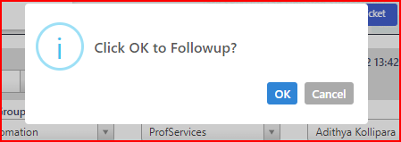

* By clicking on the OK button the Follow up will be add and display in the follow up page as shown in the below screen shot.

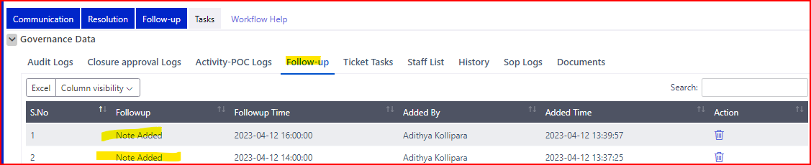

* By clicking on the TASK tab, the page should be display as shown in the below screen shot.

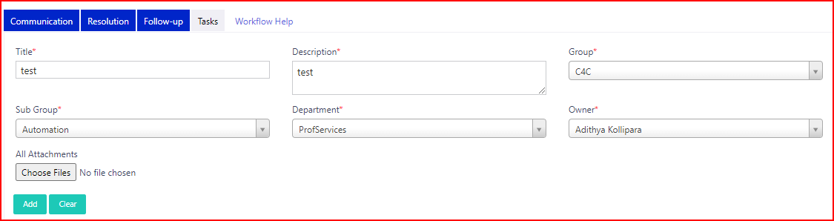

* In the TASK tab the highlighted fields should be display as shown in the below screen shot.

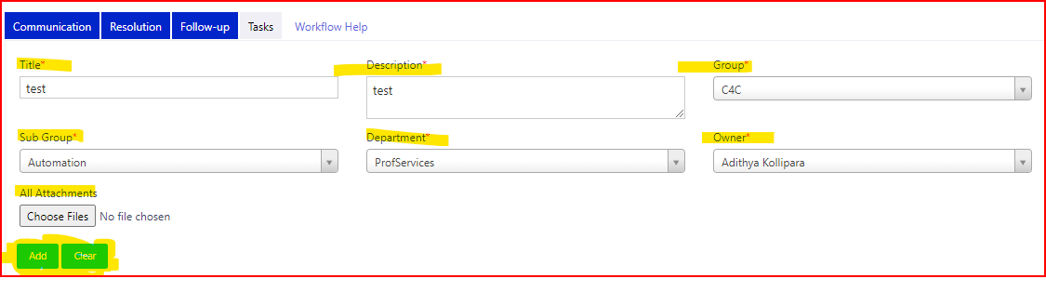

NOTE: All the Fields are mandatory along with the * symbol.

* By clicking on the ADD button the confirmation popup should be display as shown in the below screen shot.

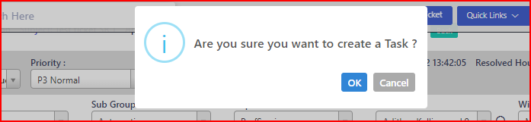

* By clicking on OK button in the Confirmation popup the task should be ADD successfully as shown in the below screen shot.

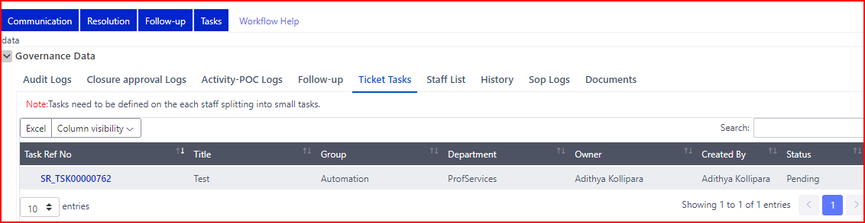

* By clicking on the WORKFLOW HELP link as shown in the Below screen shots.

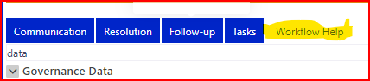

* By clicking on the WORKFLOW HELP link it will be display as shown in the below screen shot.

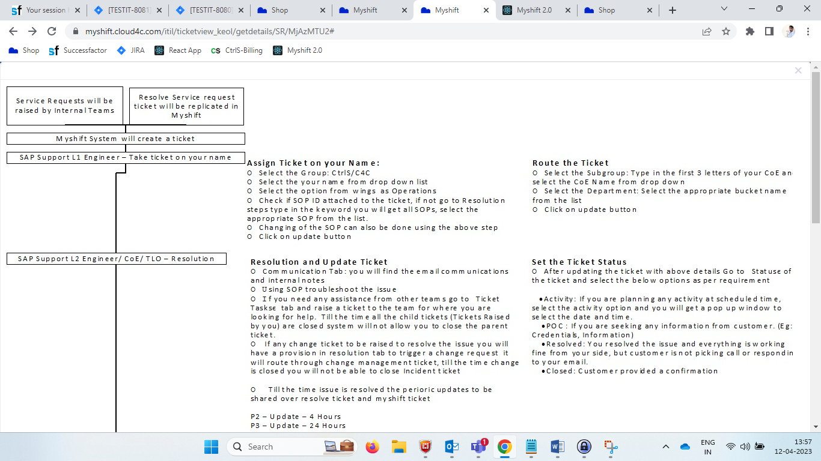

**GOVERNANCE DATA:**

* The Governance call will be display at bottom of the Communication tab along with dropdown symbol as shown in the below screen shot.

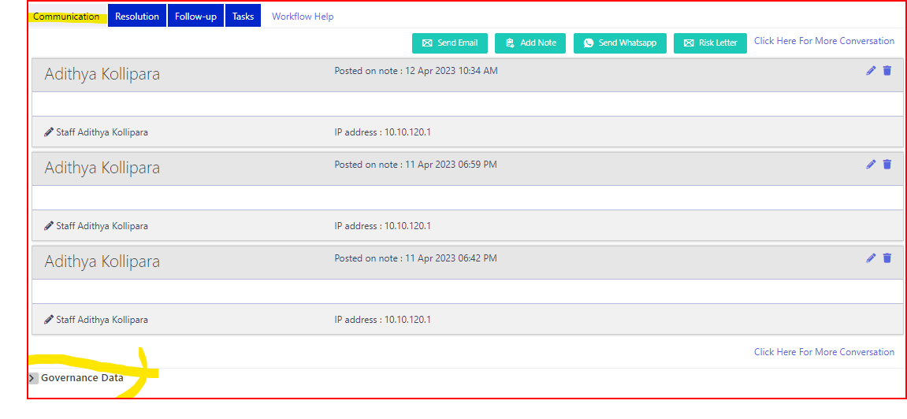

* By clicking on the Governance data tab drop down the below page will be display as shown in the screen shot.
* NOTE: By clicking Governance data tab by default Audit logs will be display as shown in the below screen shot.

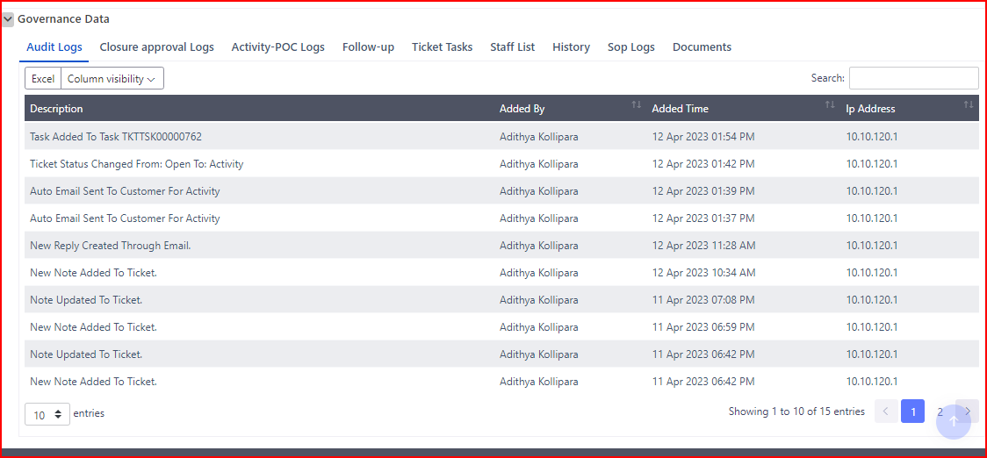

**AUDIT LOGS:**

* In Audit logs we find the step by step work flow of the ticket as shown in the below screen shot.

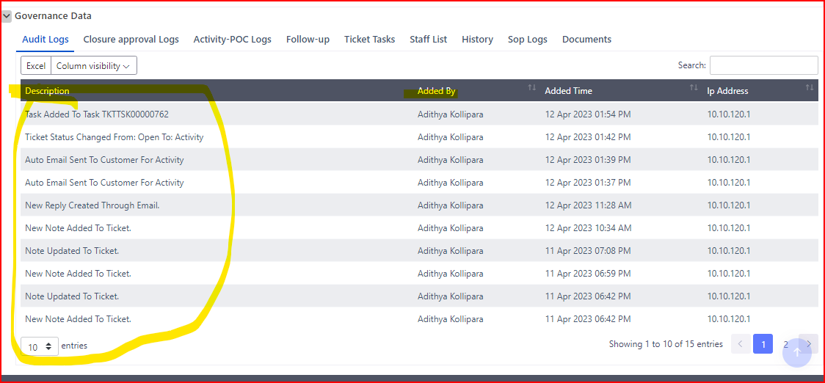

* **CLOSURE APPROVAL LOGS:**
* It will display the details of the Closure approval details as shown in the below screen shot.
* In Closure approval logs it will display the **Closure approval approved/rejected logs** and **Closure Approval Logs** as shown in the below screen shot.

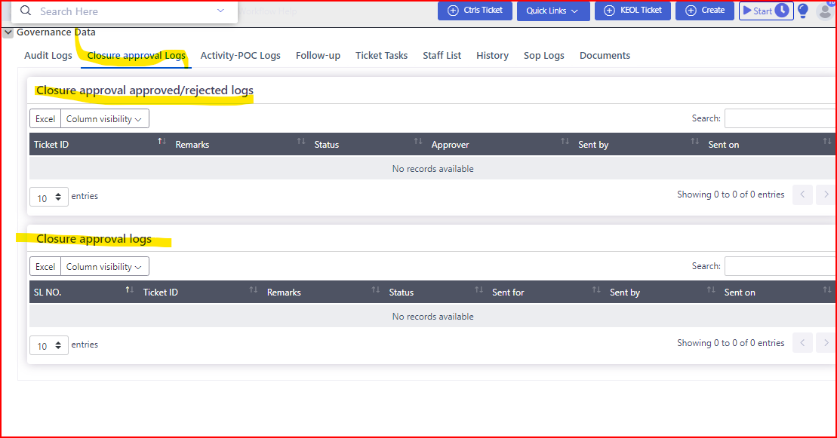

**ACTIVITY – POC LOGS:**

* In this tab we can see the Activity pending on Customer details.
* It will display when the status is in POC and they send the POC approvals to the customer.
* By clicking on the Activity – POC logs the below page is display as shown in the SCREEN SHOT.

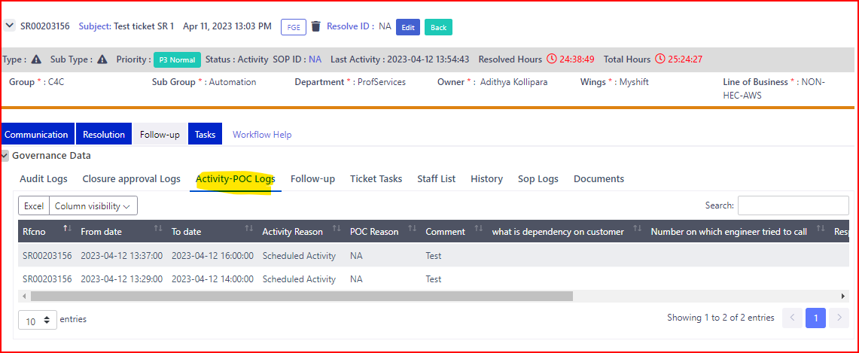

* In Activity – POC logs the below highlighted fields will display as shown in the below screen shot.

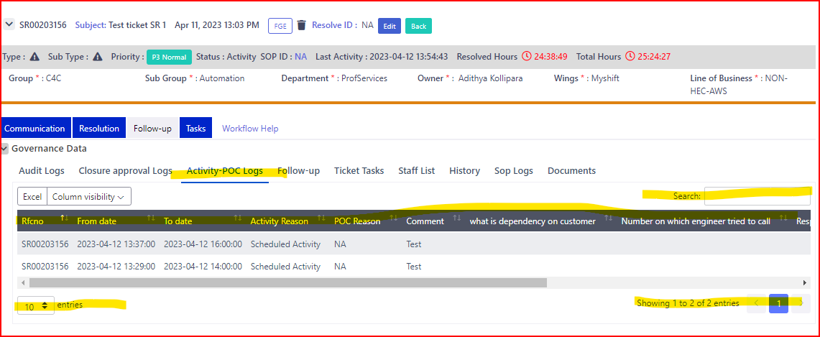

**FOLLOW UP:**

* In Follow up tab we can see the follow up details as shown in the below screen shot.

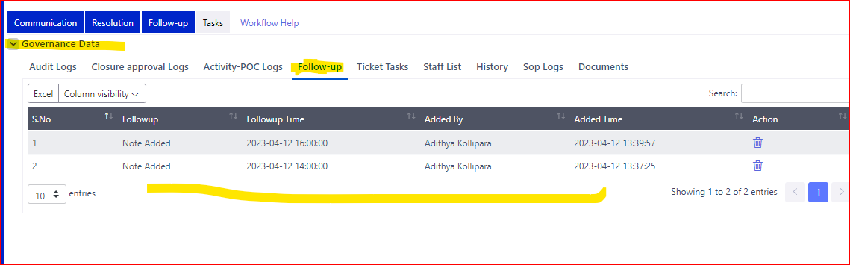

**STAFF LIST:**

* In this Staff list we will see the details of the staff who worked on this ticket.
* The staff list page will be display as shown in the below screen shot.

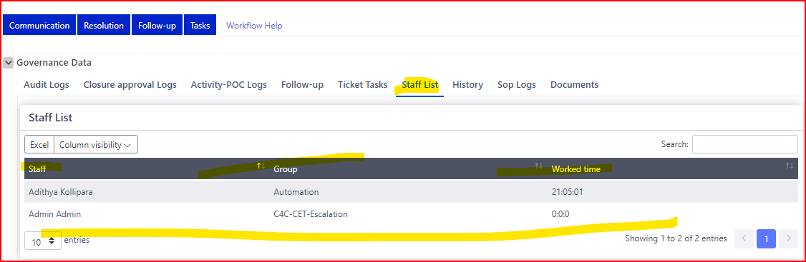

**HISTORY:**

* In Governance data tab the HISTORY will display as per the below screen shot.
* In History we can see the details of the created ticket.

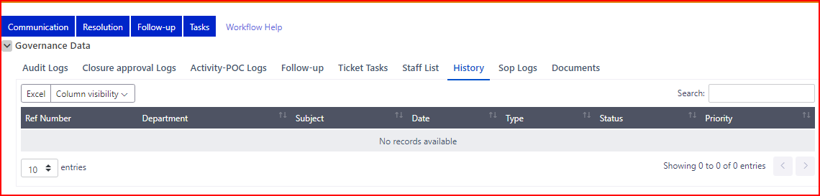

**SOP LOGS:**

* In Governance data SOP LOGS will display as shown in the below screen shot.
* In this tab the details of the SOP LOGS will be display as shown in the below screen shot.

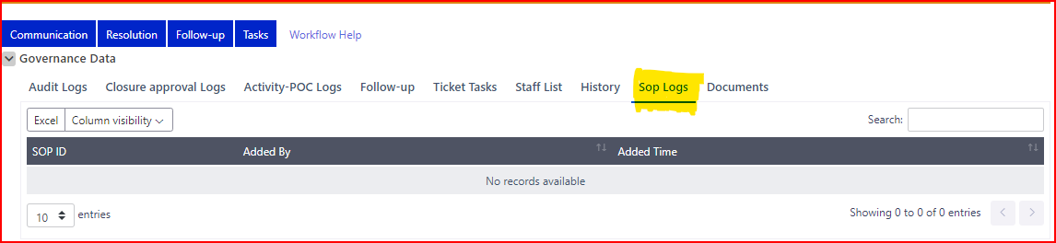

**DOCUMENTS:**

* In Governance data, the Documents will display as shown in the below screen shot.
* In Documents we can add the ticket files/ document as shown in the below screen shots.

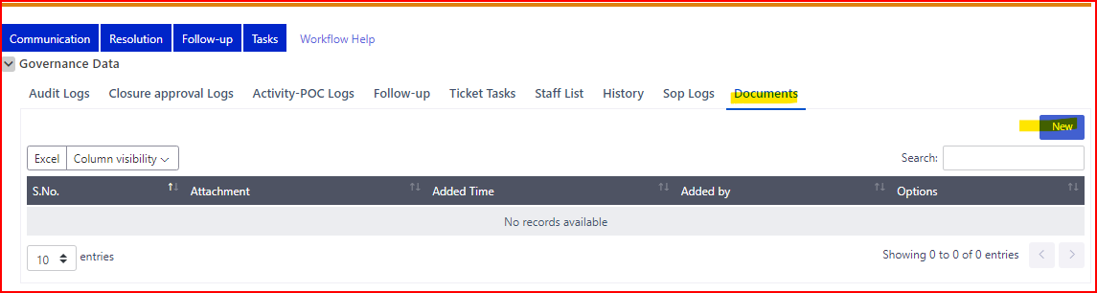

* By clicking on the NEW button the CHOOSE FILE field along with the Browse and ADD buttons as shown in the below Screen Shot.

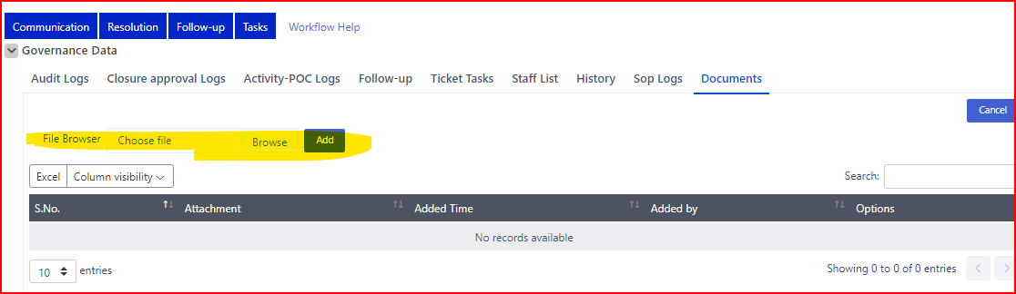

* By Clicking on the ADD button the Confirmation POPUP will be display as shown in the below screen shot.

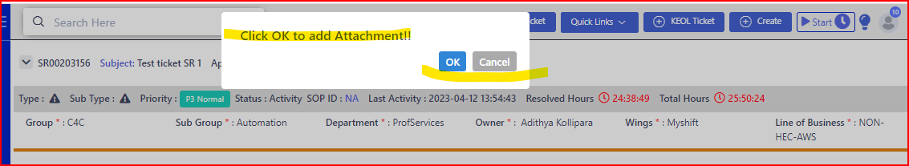

* By clicking on the CANCEL button the file upload should be cancel.
* By clicking on the OK button the document should be display as shown in the below screen shot.

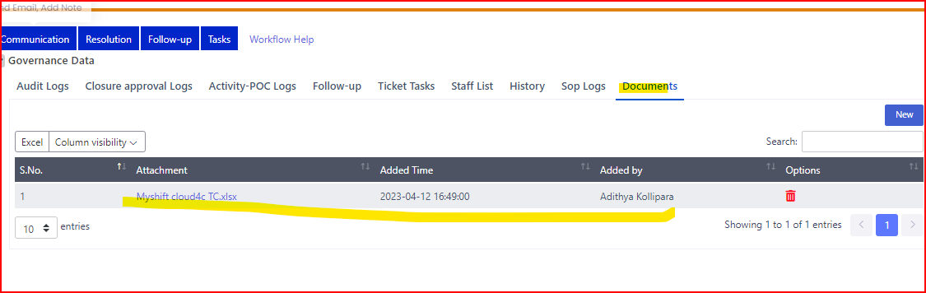

* By clicking on the DELETE icon the Confirmation POPUP should be display as shown in the below screen shot.

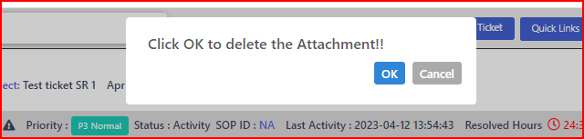

* By Clicking on OK button the Attachment should be deleted.
* By clicking on Cancel button the Attachment Should be cancel.

**TICKET TASK:**

* In this page we can see the created sub tasks as shown in the below screen shots.

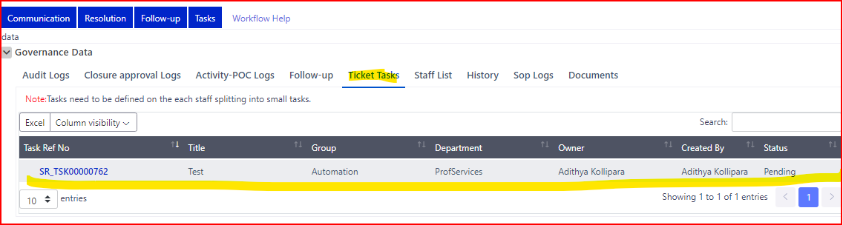

* In the **TICKET TASKS** Page, the details should be display as shown in the below screen shots.

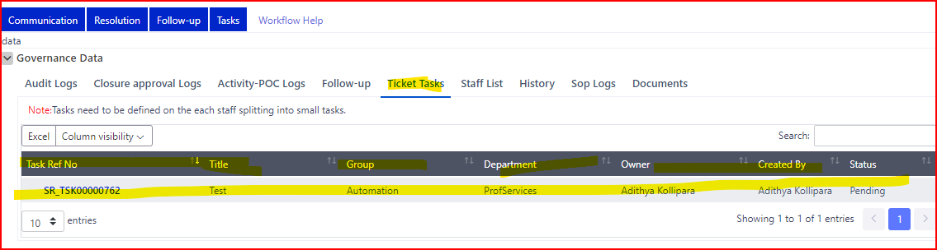

* Click on the Task Ref in the Ticket task model at Governance data as shown in the below screen shot.

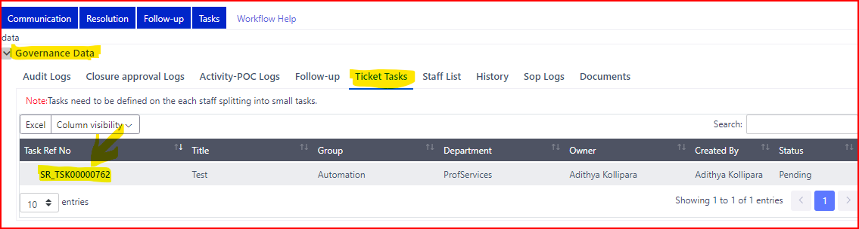

* By clicking on the task ref no, the ticket will be open as shown In the below screen shot.

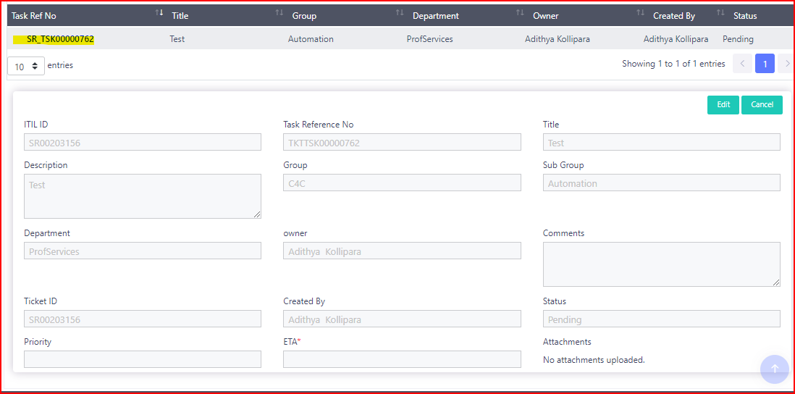

* In the Sub task ticket, the Details should be display as shown in the below screen shot.

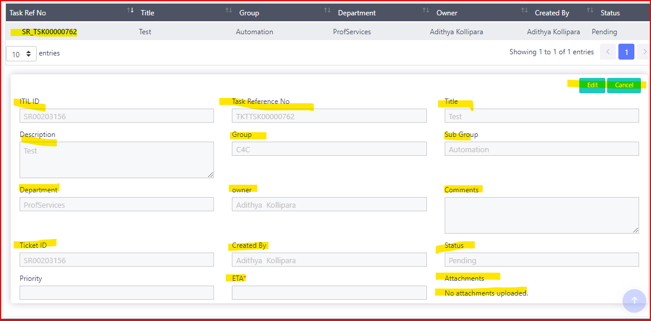

* Click on the EDIT button in the sub task ticket as shown in the screen shot.

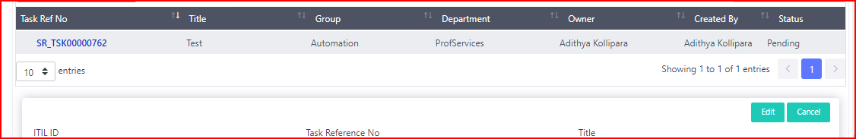

* By clicking on the edit button the Confirmation page should be display as shown in the below screen shot.

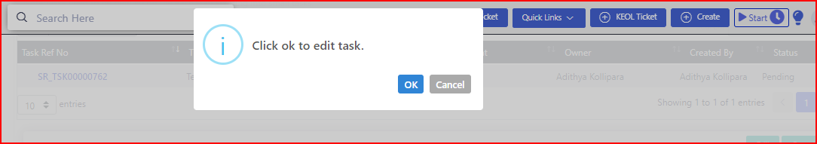

* By clicking on the OK button in the Edit task confirmation POP UP the page should be editable mode as shown in the below screen shot.

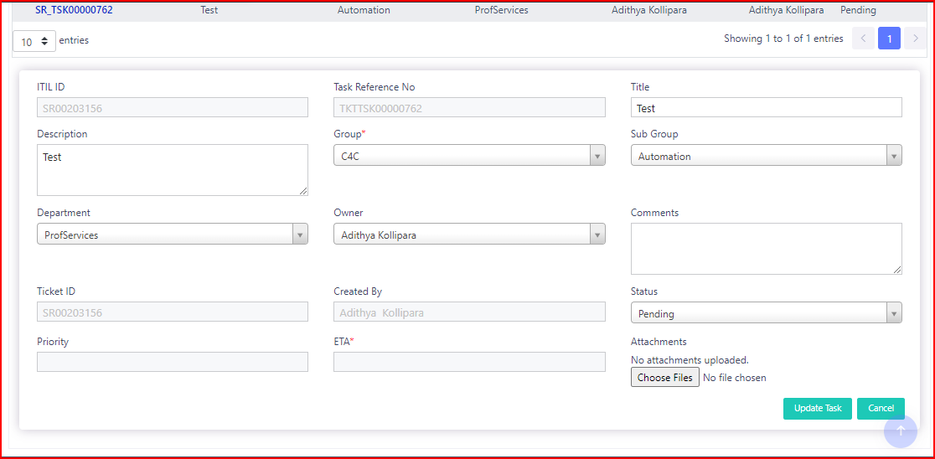

* By clicking on the Edit button the below highlighted fields should be display as shown in the screen shot.

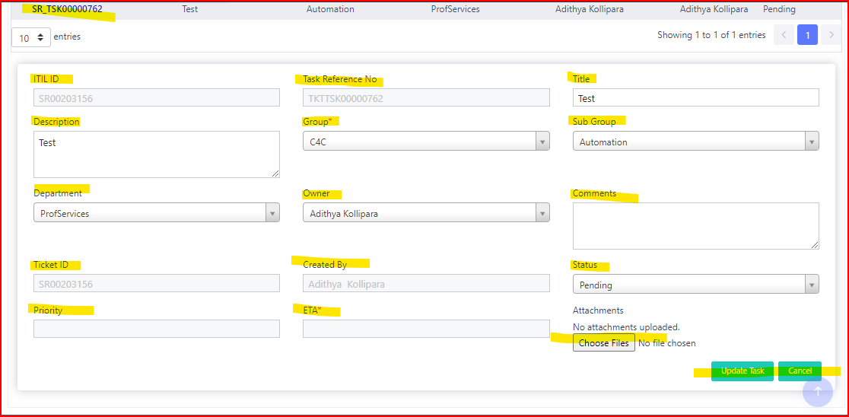

* By clicking on the UPDATE task the confirmation POPUP should be display as shown in the below screen shot.

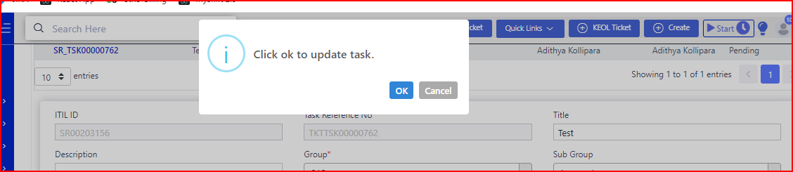

* By clicking on the **OK** button the task should be updated
* By clicking on the **CANCEL** button the task should be cancel.
* By clicking on the **STATUS** drop down as show in the below screen shot.

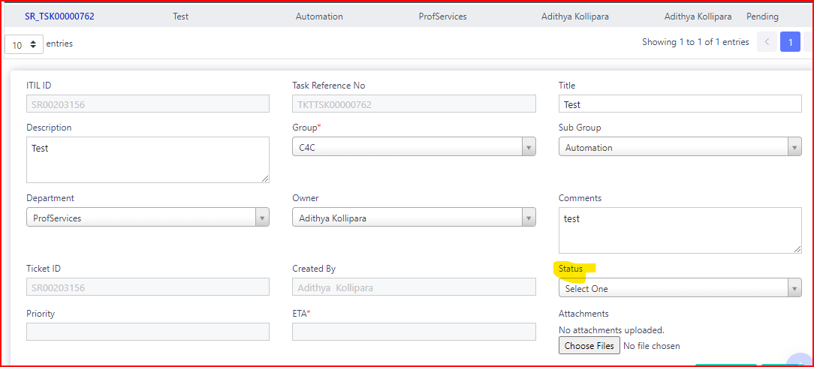

* By clicking on the Status Dropdown the below details should be display as shown in the below Screen shot.

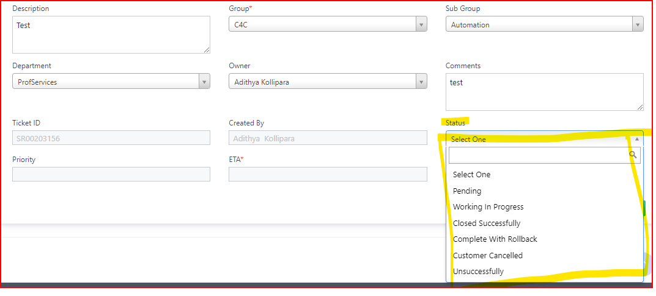

* By keeping status as closed successfully the page will be display as shown in the below screen shot.

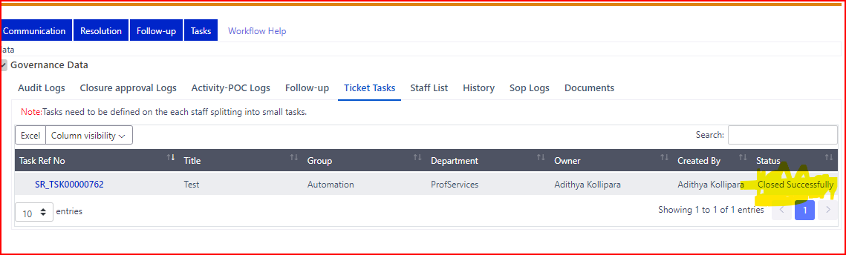

* Now update main ticket status to Pending On Customer As shown in the below screen shot.

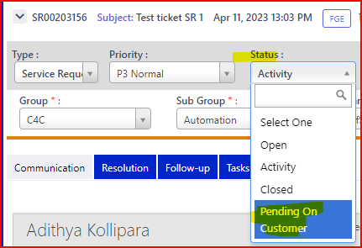

* Change the Status into Pending on Customer, the POC details popup will display as shown in the below screen shot.

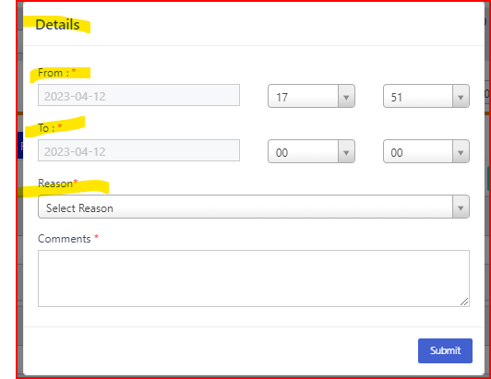

* In the reason dropdown the below details should be display as shown in the below screen shot.

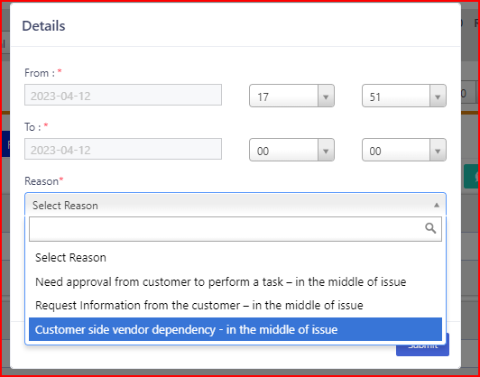

* By clicking on the Submit button the details confirmation popup should be display.

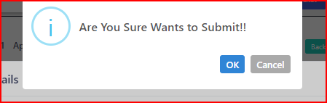

* By clicking on the CANCEL button the details page should be cancel.
* By clicking on the OK button in the POC details page, the details page should be submitted successfully
* Now change the status from POC to POM as shown in the below screen shot.

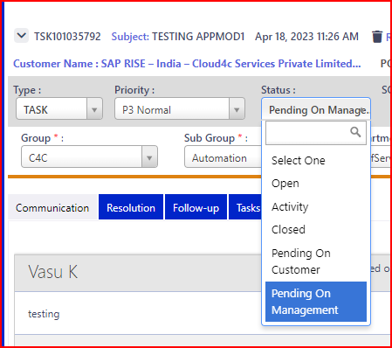

* Select POM and click on Update.
* By selecting the POM the Page will be display as shown in the below screen shot.

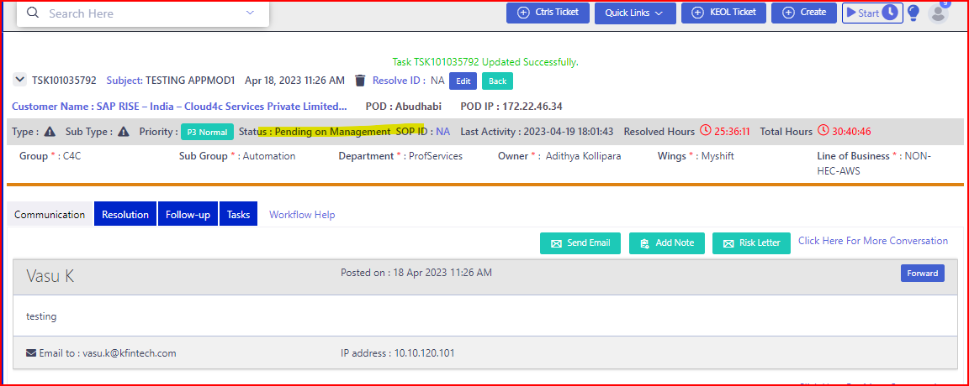

* Now change the status from POM to Closed as shown in the below screen shot.

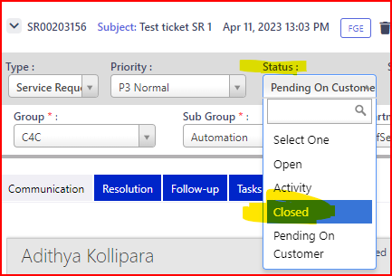

* By selecting the Closed status the Closer Approval details POPUP will display as shown in the below screen shot.

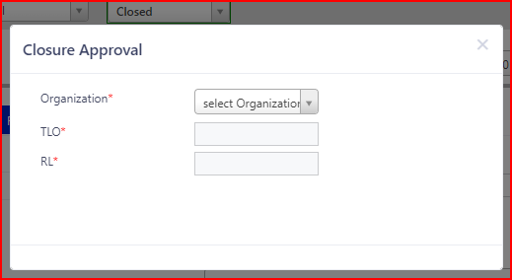

* The below highlighted details should be display in the Closer approval details popup as show in the below screen shot.

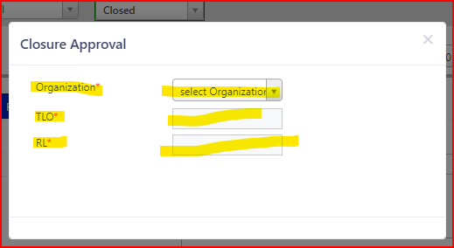

* Based on the organization selection the TLO and RL fields will be enable and display the details in the dropdown list as shown in the below screen shot.

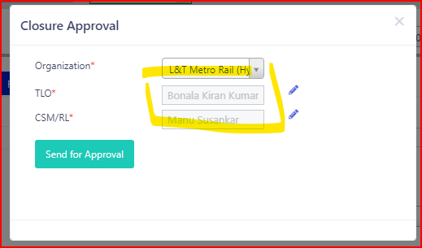

* By clicking on the Send Approval button the Confirmation POPUP will be display.

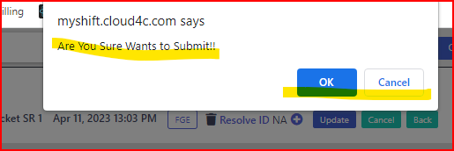

* By clicking on the Cancel Button the Closer approval will be cancelled.
* By clicking on the OK button in the Closer Approval, the details will be submitted successfully.

**NOTE:**

* Here the closure approval process will be done by the TLO and CSM/RL based on Organization selection.
* **Before updating the Status to closed state the resolution tab will be display as shown in the below screen shot**.

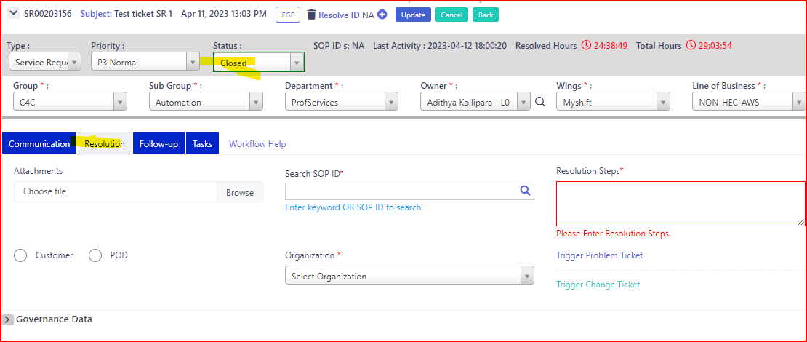

* Resolution tab is mandatory for all the tickets type before closing the ticket.
* By updating the Status as closed the page will be display as shown in the below screen shot.

